DNA Extraction for high‐throughput sequencing
Student Handout for Full Semester

DNA extractions will be performed using the Qiagen DNeasy Blood and Tissue DNA Extraction kit. The protocol has been slightly modified from the kit’s standard extraction protocol to optimize results for insect microbiomes. Reagents for this protocol will have been aliquoted by your instructor for each group (4 students) and contains enough material for 2 DNA extractions. Each group of 4 students will process 1 beetle from each treatment (assuming you have 2 treatments), for a total of 2 beetles per group, one beetle per each pair of students. In addition, one group from each lab section also will be asked by your instructor to complete a negative control DNA extraction (consisting of all the steps in the DNA extraction process, but without a beetle sample.) The procedure below is for the DNA extraction of a single beetle.

Procedure
1. With a permanent marker, carefully label a sterile 1.5mL microcentrifuge tube with the following information:
a. Your group name/number
b. Beetle ID #
c. Experimental Treatment Group
2. Select a beetle for DNA extraction and place it in the labelled microcentrifuge tube. Use one beetle per tube.
3. For the beetle selected, make sure to record the following information in your
notebook.
a. Group members names
b. Beetle ID #
c. Beetle life cycle stage (egg, larva, pupa, adult)
d. Beetle sex (if adult)
e. Beetle host bean type
f. Experimental Treatment Group
4. Freeze the beetle at ‐20°C or ‐80°C for 5 minutes. Then take the tube back to your lab bench.

Surface Sterilization
1. Holding a beetle with forceps, surface sterilize the beetle by dipping beetle in
a. 10% Bleach (3 seconds)
b. Sterile Water (10 seconds)
c. 70% Ethanol (5 seconds)
d. Sterile Water (10 seconds)

2. Place the surface sterilized beetle in a new appropriate labelled sterile 1.5mL microcentrifuge tube.

DNA Extraction
1. Add 180uL of buffer ATL and crush the beetle using a sterile microtube pestle. When
the beetle is fully crushed, the mixture will be cloudy with small fragments of the beetle.

The microtube pestle should be saved for cleaning, autoclaving and re-use.

2. Put on gloves and safety glasses. Add 20uL proteinase K. Then add 200uL Buffer AL. Mix thoroughly by vortexing for 10 seconds. Incubate at 56°C for 10min.

Note: If you are not to perform the full extraction, you should stop after adding proteinase K. Vortex for 10 seconds and seal your tube with parafilm. Stopping at this point is appropriate if your sample is to be extracted by a laboratory assistant, another laboratory group, or in another laboratory meeting.

3. Add 200uL of 96‐100% ethanol to the sample, and mix thoroughly by vortexing for 10
seconds.

4. Label a DNeasy Mini Spin column with your sample name. Then place it in a new 2mL collection tube (or 1.5mL microfuge tube). The collection tube collects waste reagents.

5. Pipet the resulting mixture from step 3 into the labeled DNeasy Mini spin column you placed in a collection tube in Step 4. Focus on pipetting up as much of the liquid (600uL) as you can, even if that means transferring up some beetle parts. You don’t have to transfer the whole beetle, although it is okay if you pick up some beetle parts in addition to liquid during transfer.

6. Centrifuge at 10,000g for 1min. Remember to balance tubes in the rotor. Lock the round lid on the rotor before closing the external lid.

7. After centrifuging in Step 6, place the labeled DNeasy Mini spin column in a new 2mL collection tube (or a new 1.5uL microfuge tube). Discard the old collection tube containing the flow‐through from the centrifugation.

8. Add 500uL of Buffer AW1 into the DNeasy mini spin column.

9. Centrifuge for 1 minute at 10,000g.

10. Place the labeled DNeasy Mini spin column into a new 2mL collection tube. Discard the old collection tube containing the flow‐through from the centrifugation.

11. Add 500uL of Buffer AW2.

12. Centrifuge for 3 minutes at 20,000g (or the top speed of your centrifuge if less than 20,000g) to dry the DNeasy Mini spin column membrane.
The membrane MUST be dry and the tip of the column should not come into contact with the flow‐through, because the flow‐through contains ethanol, which may interfere with sequencing of the DNA. If any residual ethanol touches the column tip, empty the collection tube, then reuse it in another centrifugation for 1 minute at 20,000g.

13. Very carefully (ensuring that the bottom tip of the column does not contact the flow‐through in the collection tube) place the DNeasy Mini spin column in a clean and sterile 1.5mL microcentrifuge tube labelled on both the top (lid) and side as follows:
a. Your group name/number
b. Beetle ID # and treatment, on the side of the tube also print: DNA

14. Once the DNeasy Mini spin column is in a sterile 1.5ml microcentrifuge tube, pipet 100uL of molecular grade, sterile, nuclease free water directly onto the DNeasy Mini Spin column’s membrane. Do not allow the pipette tip to touch the membrane.

Make sure the water goes directly onto the membrane. If water droplets rest on the sides of the inner column walls, carefully pipette up droplet and pipette out directly onto the membrane.

15. Incubate at room temperature for 1min.

16. Carefully load the microcentrifuge tube with column into the centrifuge rotor as shown in the photo, with the outside of the hinge and lid facing up. The lid of the microcentrifuge tube will need to stay open, as it cannot properly close with the DNeasy Mini spin column inside the tube.

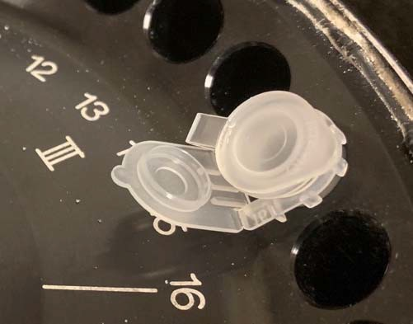
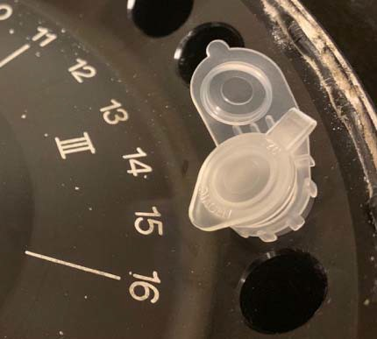
Try not to touch the inside of the lid with your fingers to avoid contamination. If your centrifuge rotor has a lid that must be secured into place before starting, carefully place the tubes such that the lids of the tubes do not prevent the centrifuge from closing properly.

17. Centrifuge for 1 min at 16,000g to elute DNA into the microcentrifuge tube. The liquid in this tube contains the extracted DNA. Remove and discard the column. Close the lid on this tube containing extracted DNA and SAVE THIS TUBE.

18. If you are quantifying your DNA, follow the instructions provided by your instructor.
Record the DNA concentration and purity in your notebook.

19. Seal the lids of the tube closed with a small piece of parafilm.

20. When finished, check your labels one last time to make sure that they are clearly written in a way that someone else can read them. Give your tubes to your instructor.

