Microbial Community Analysis Using Colony Phenotype Database
Student Handout
Objectives

  - Manipulate large datasets to conduct community-level ecological analyses
  - Use community-level data to address questions about insect microbiomes
  - Use Excel or RStudio programs to calculate community ecology variables
  - Compare microbial community using community ecology variables

Introduction

Microbiomes are the communities of microbes (bacteria, viruses, fungi and archaea) living symbiotically with all metazoans. In the past decade, both interest and research on microbiomes, including their implications for human health, have increased dramatically (Christian et al. 2015, Costello et al. 2012, McFall-Ngai et al. 2013, The Human Microbiome Consortium 2012, Young 2016). Insects have been used as model species to study the importance of microbiomes, because of their ease of use and the fact that microbial communities play diverse roles in insects (Engel and Moran 2013).
The data that are collected in any microbiome study consists of lists of the taxonomic units identified and their abundance. The same types of data are evaluated in an ecological community analysis, but now the communities are the collections of microbes that constitute different microbiomes. The community variables, “species” richness and relative abundance, are the same and the statistical methods used to compare communities, diversity and difference indices, also are the same. Perhaps the simplest measure of community structure used by ecologists is “species” or taxon richness, a count of the number of unique taxa in a sample. However, species richness does not consider the relative abundance of species in a community. Imagine two communities with five different species. In one community, all of the species have the same relative abundance. In the other community, one species dominates comprising 95% of individuals in the community. The other four species are very rare. Based on species richness as a measure of community structure, these two communities are the same, although they are clearly very different. As a result, ecologists use other species diversity indices that consider both the number of species and the relative abundance of species in a community. Two common indices are the Simpson Index and the Shannon-Weaver Index. Communities with greater numbers of species and higher evenness (i.e., similar relative abundance of species within a community) are considered more diverse. Finally, measures of species richness and species diversity do not consider the identity of species in a community. So, communities could have the same level of species diversity, but have completely different species. Measure of community similarity, such as the Bray-Curtis Index, compare the similarity (or dissimilarity) between two communities based on the identity of species in the communities, as well as their relative abundances. For more information on indices of species diversity and measures of community similarity, see Krebs (1999).

In this study, bean beetle gut microbiome data were collected by undergraduate students using the protocols developed by Cole et al. (2018). Three types of data were collected: colony phenotypes from cultured bacteria, 16s rRNA gene sequencing of specific bacterial colonies, and whole community 16s rRNA gene sequencing, but we will limit our analyses to the colony phenotype and colony-based 16s data.

Microbial Community Analysis Using Colony Phenotype Database
Questions
Using data from the colony phenotype database and the analyses described below, answer the following questions.
- Based on the diversity indices that you calculated, which treatment had the highest (lowest) diversity?
- Does the answer depend on the measure of species (taxon) diversity that you use?
- Is there a relationship between number of samples and taxonomic diversity? If so, what might explain this?
- Which communities are most similar (different)?

Database description
This database contains data for the microbial community of bean beetles based on colony phenotypes of individual bacterial colonies cultured from bean beetle homogenates plated on different media. The bacteria cultured from each beetle are represented by multiple rows of data with each row representing a different combination of phenotypic characters. A unique combination of phenotypic characters is taken to represent a unique bacterial taxon.
Access the database at https://www.beanbeetles.org/microbiome/phenotype-database-search/.
The database allows you to limit your search by bean host species, sex, life cycle stage, media on which bacteria were grown, and colony phenotype. EMB and PEA plates select for gram negative and gram positive bacteria, respectively. So, a colony with a particular combination of phenotypic characters on an EMB plate is a different bacterial taxon than a colony with the same combination of characters on a PEA plate. The same is not true if we include blood agar or nutrient agar plates in our sample. Those plates could be considered independently.
We want to limit our search to PEA and EMB plates (or Nutrient Agar only). After limiting by media type, click “Submit.”
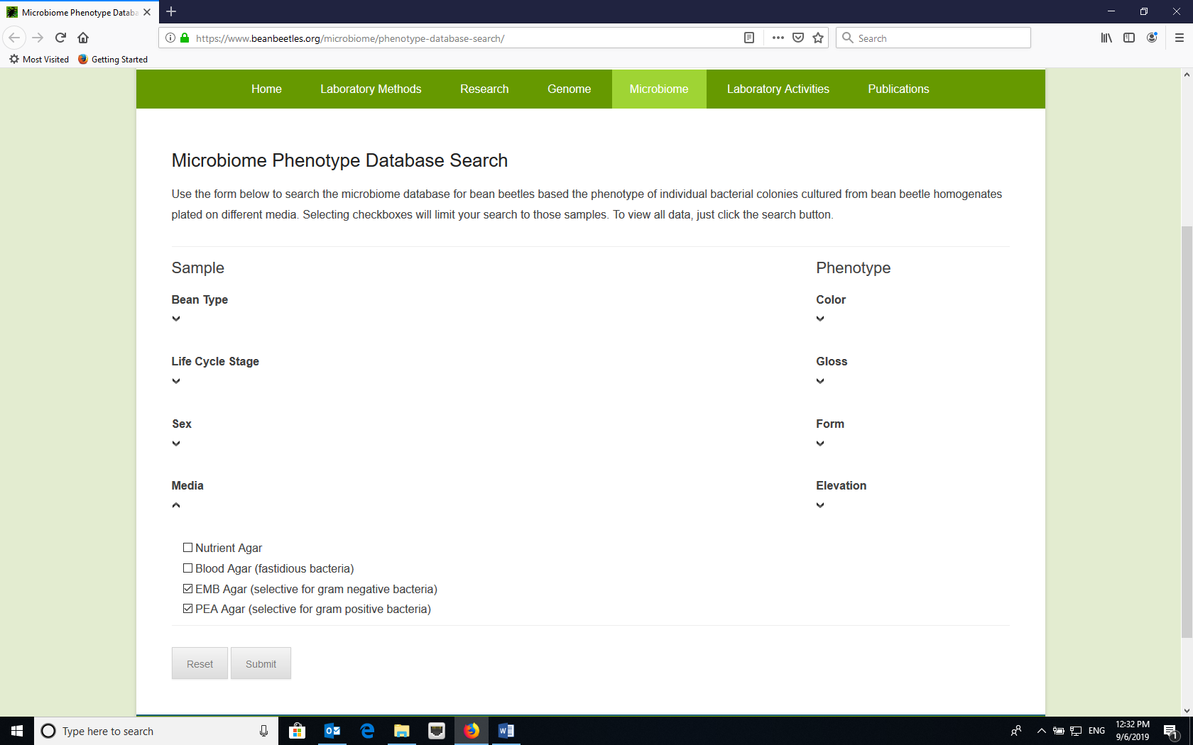
Select “EMB Agar” and “PEA Agar”

Downloading Data
While we can view the data on the website, we want to download the data to manipulate. Click the download link to download a csv file with the data. Then, re-save the file as an Excel file and rename the tab “raw data.”
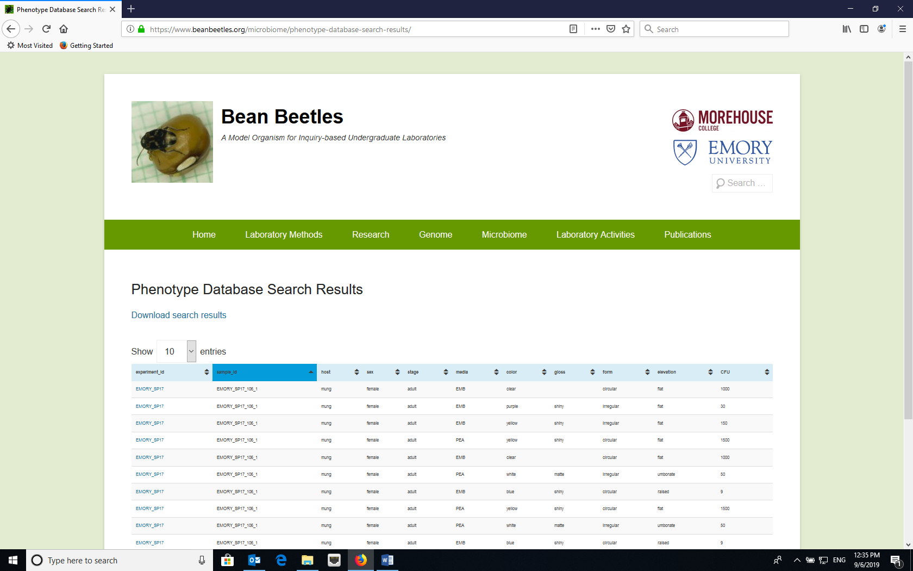
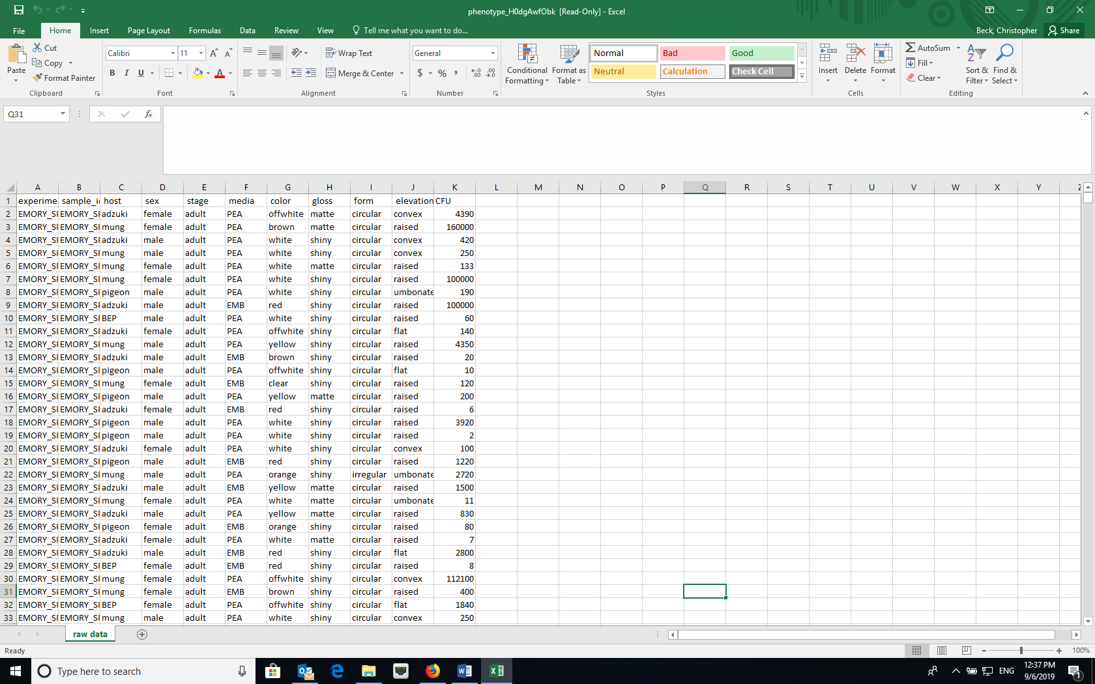
Double click and relabel tab as “raw data”

Data manipulation
- The raw data have some missing values for phenotypic characters or values of zero for CFU (colony forming units) (which represents missing data for CFU). These rows need to be deleted. The easiest way to do this is with the Filter function in Excel. In the “raw data” worksheet, turn on filtering by selecting Filter under Sort and Filter.

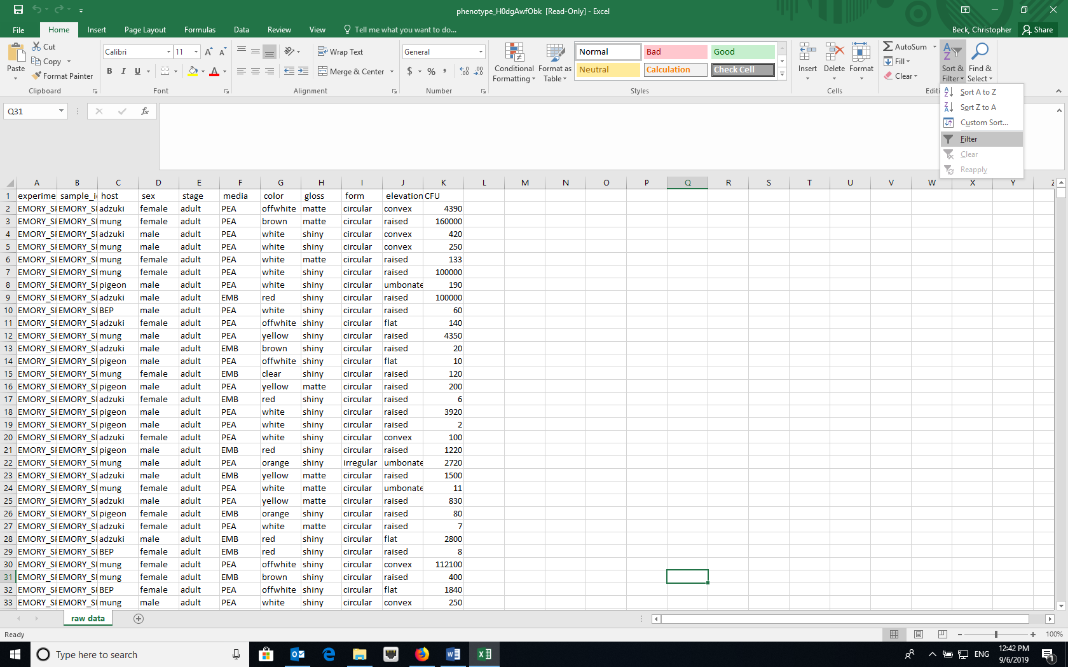

Then, for each of the phenotypic characters, click the down arrow in the column heading and unselect “Blank” at the bottom of the list and unselect “0” in the CFU column.

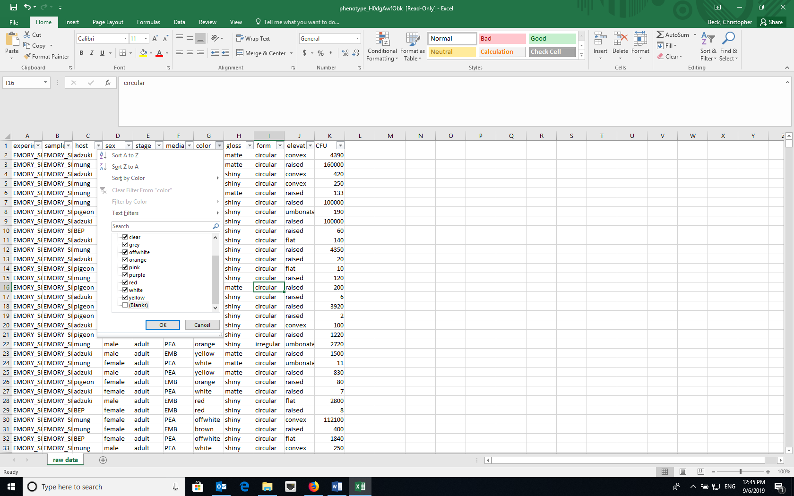
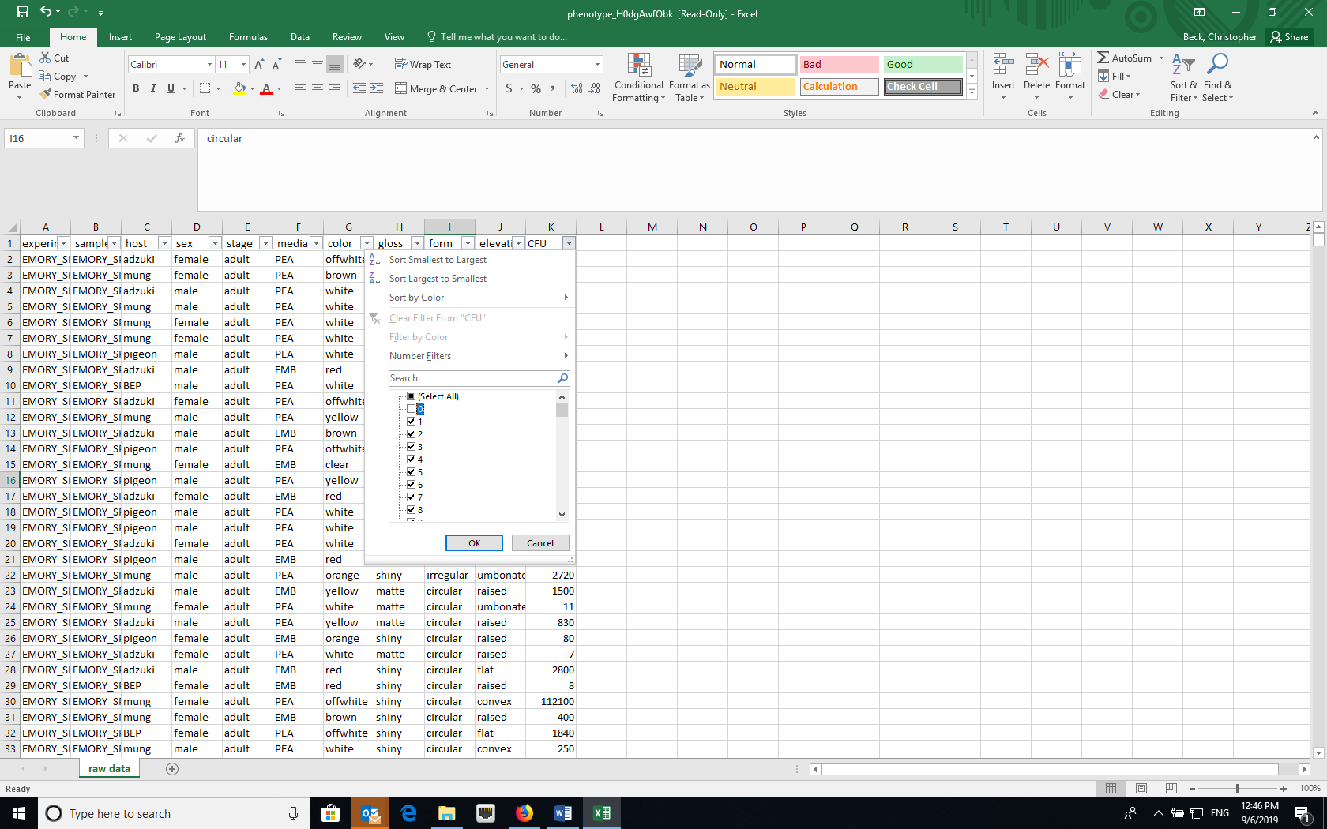

Next, select all (CRTL-A or CMD-A) and copy and paste into a new worksheet and name that sheet “phenotype”. The “phenotype” worksheet represents the cleaned raw data. If you will be analyzing the data in R later, copy and paste a second time into another blank sheet and name that sheet “community”.
- With our new “phenotype” dataset, we need to define a bacterial “taxon” based on the combination of media and the four phenotypic characters (color, gloss, form and elevation). One way to do this is to create a “taxon” name by concatenating the media and the four different phenotypic traits. You can do this using the CONCATENATE function in Excel (=CONCATENATE(F2,G2,H2,I2,J2). After you create the “taxa” names, you might want to select the column and then re-paste it in the same column by pasting values (using paste special) to remove the formula.

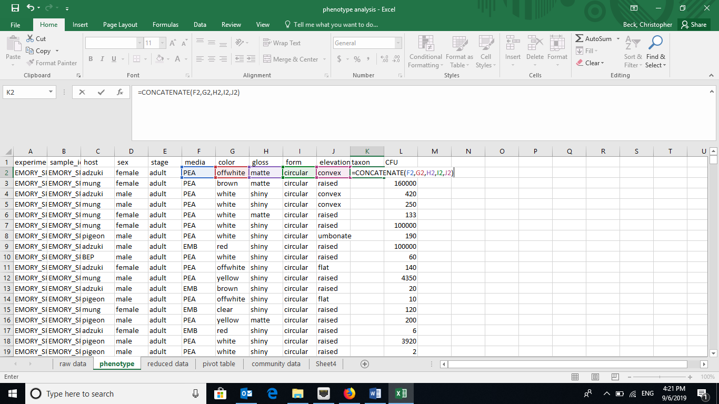
Insert a new column for “taxon” then in the first blank cell of the column insert the formula =CONCATENATE(F2,G2,H2,I2,J2). Then, copy the formula down for the rest of the column.

- Now, we need to consolidate the data for each host species, each sex, or the combination of the two by the bacterial taxa. The easiest way to do this is with the Pivot Table function in Excel.
- When clicked on a cell within the data, create a Pivot Table (Insert -> Pivot Table OR Data -> Summarize with Pivot Table, depending on your version of Excel). Make sure that the data source includes the top row, which has the column headings.

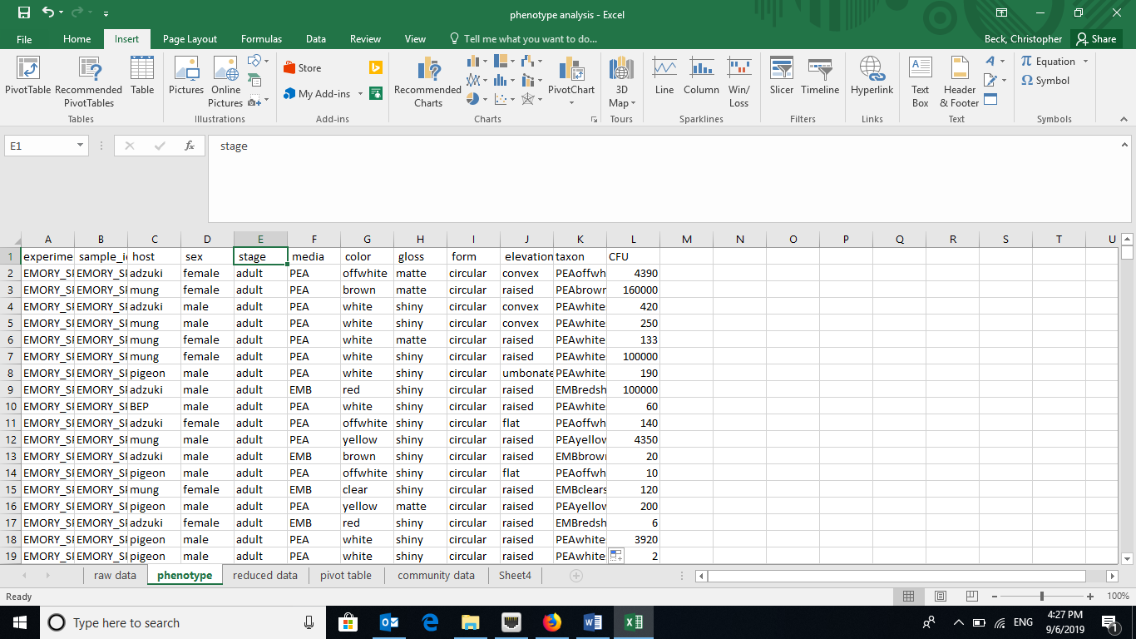

Set the host and sample_id as the rows as these represent the treatment and individual communities, respectively. The new “taxon” column should be the columns in the pivot table. The Values should be a SUM of the CFU (colony-forming units, a measure of density), which will be shown as “SUM of CFU” using the Options menu.

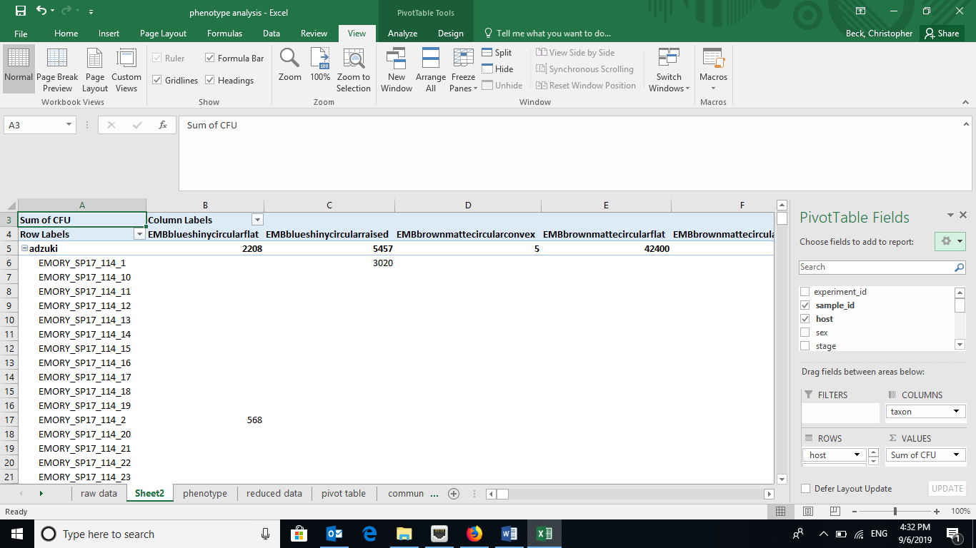
Add “taxon” to COLUMNS, “host” and “sample_id” to ROWS, and “CFU” values.

- You can add zeros to all of the empty cells in the Pivot Table using the Options menu.

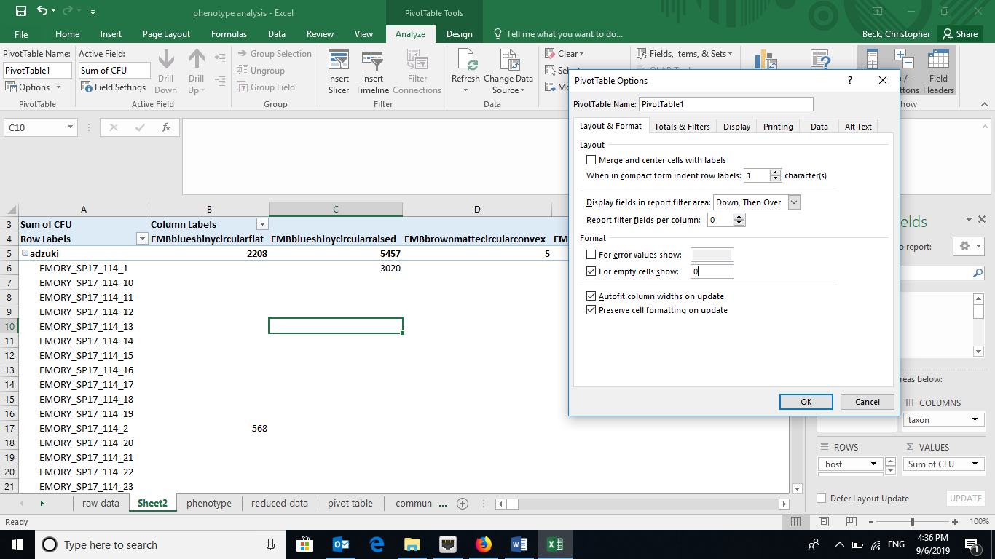

- Remove the Grand totals for Columns using the Options menu or the Design tab depending of your version of Excel.
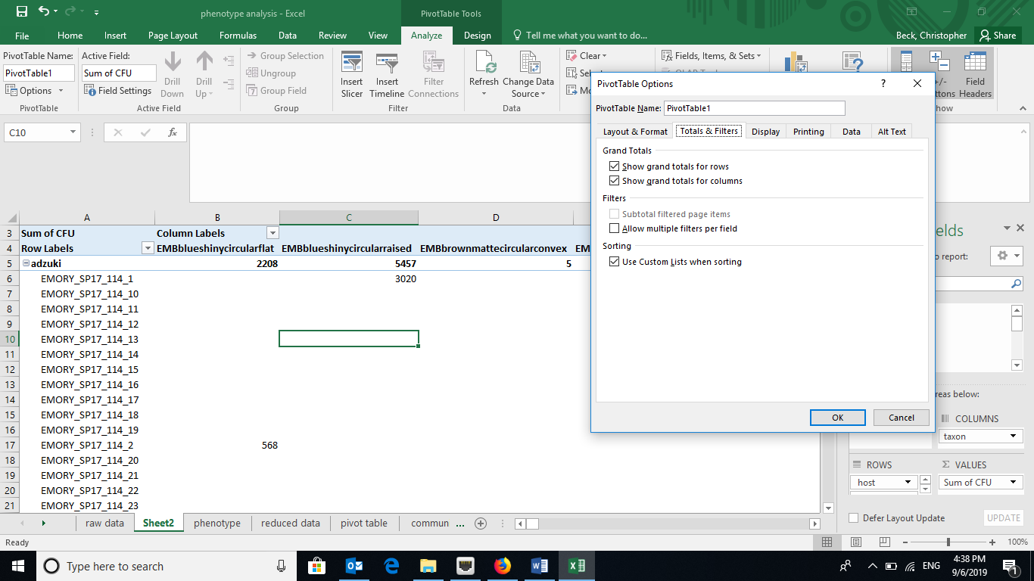
Unselect check boxes for grand totals for columns.

- To get the treatment data to repeat for each sample, in the Design tab, select “Report Layout” and choose “Show in Tabular form” and “Repeat All Item Labels”.

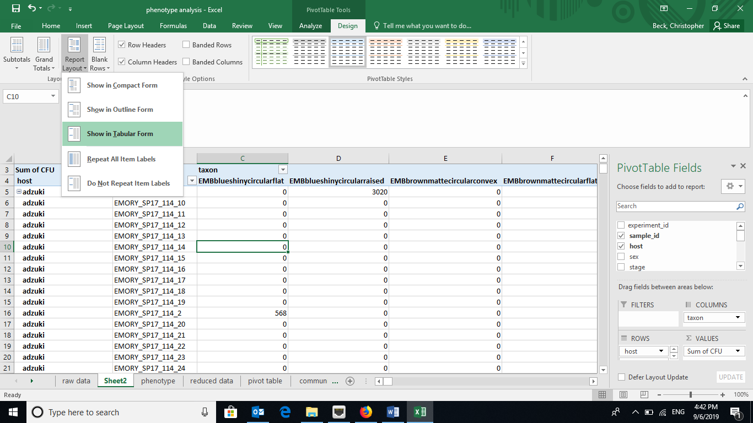

- Copy and paste (as values) the pivot table to a new worksheet and remove any extra rows at the top. Each of the columns in this new worksheet represents a unique bacterial taxa. The exact phenotype doesn’t matter, so we are going to rename them species_1, species_2, …. Title this worksheet tab “community data”.
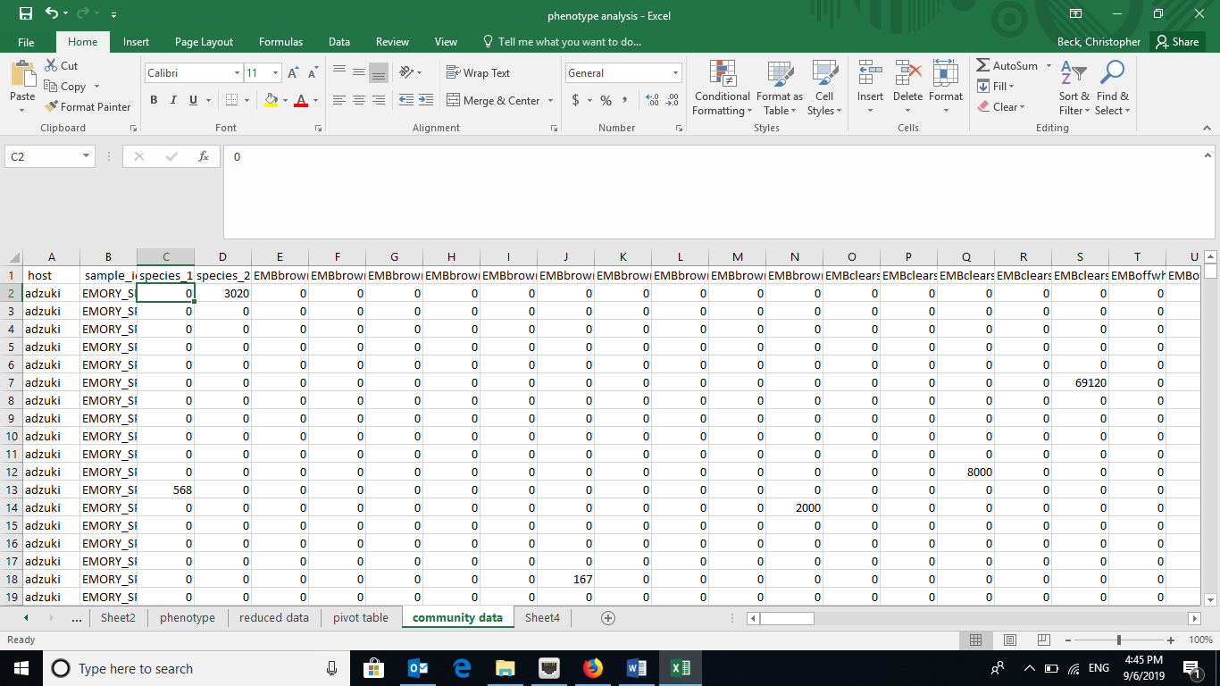
Rename columns “species_1”, “species_2”, etc.
Rename tab “community data”.

Calculating diversity indices
- Species (taxon) richness – the number of unique species (taxa) in a sample
  - Although you could manually count the number of cells with values greater than zero for each treatment, using the COUNTIF formula in Excel is easier (e.g., =COUNTIF(range,”>0”) where “range” the is range of cells in the spreadsheet containing the data, such as “C2:EW2”).

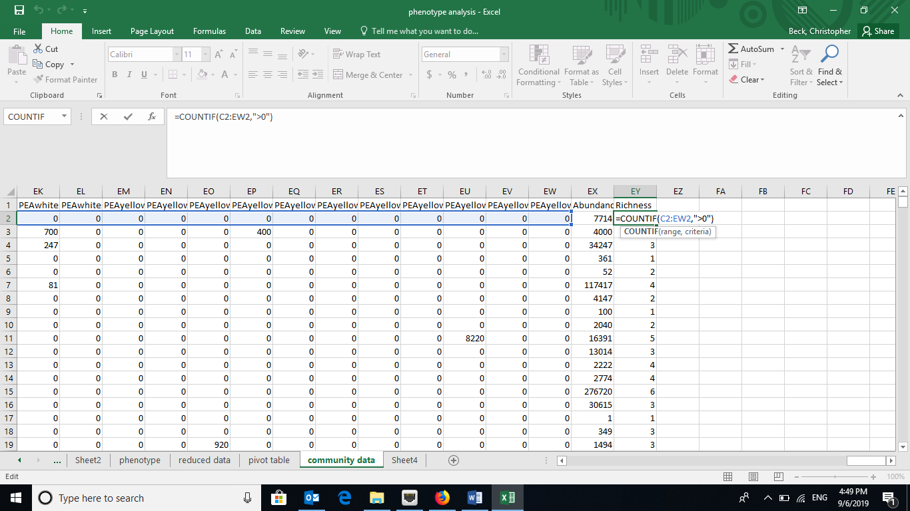
- Simpson Index – the Simpson Index incorporates both species (taxon) richness and species (taxon) evenness.
  - D = Ʃ(n/N)^2, where n=number of individuals of a particular species (taxon) and N=total number of individuals in a sample. D increases as diversity decreases, which is counterintuitive. A reciprocal or inverse index would be more intuitive and are easily calculated.
  - Reciprocal Simpson = 1/D and scales so the maximum value is the species richness of a community.
  - Inverse Simpson = 1-D and scales to a maximum value of 1.0.
  - Create a new data array below the original using the same row labels (treatment variables) and the same column labels (species).

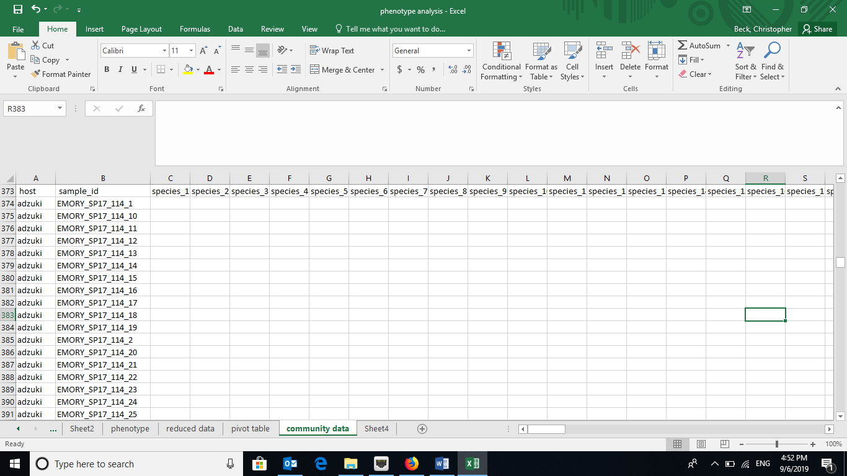
  - To calculate the proportion squared for each taxa, use the grand totals for each treatment. Using the Excel trick that $ before a column or row prevents Excel from iterating when copying a formula makes this easy. For example, =(C2/$EX2)^2. Copy the formula across the row and then down.
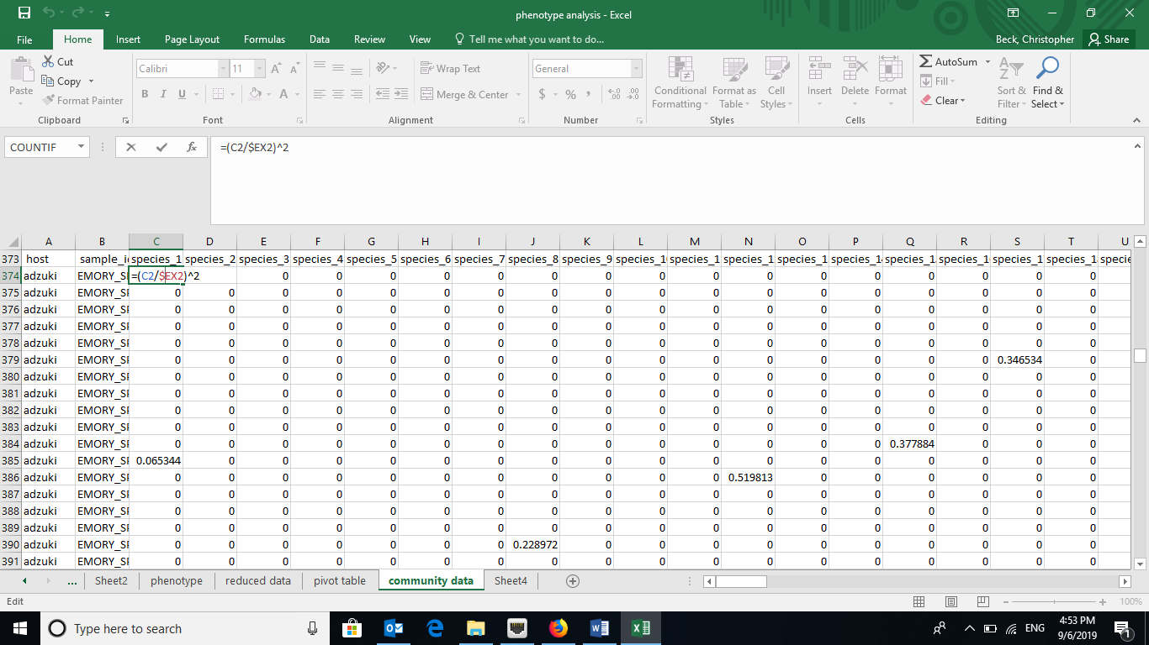
=(C2/$EX2)^2. C2 is the cell with the abundance of “species_1” and EX2 is the cell with the grand total for a sample (that row). The $ prevents the column identifier from changing. Copy the formula across the row and then down.

  - Calculate the sum of the proportions squared (=SUM in Excel for each row, a different microbial community) to calculate the Simpson Index.

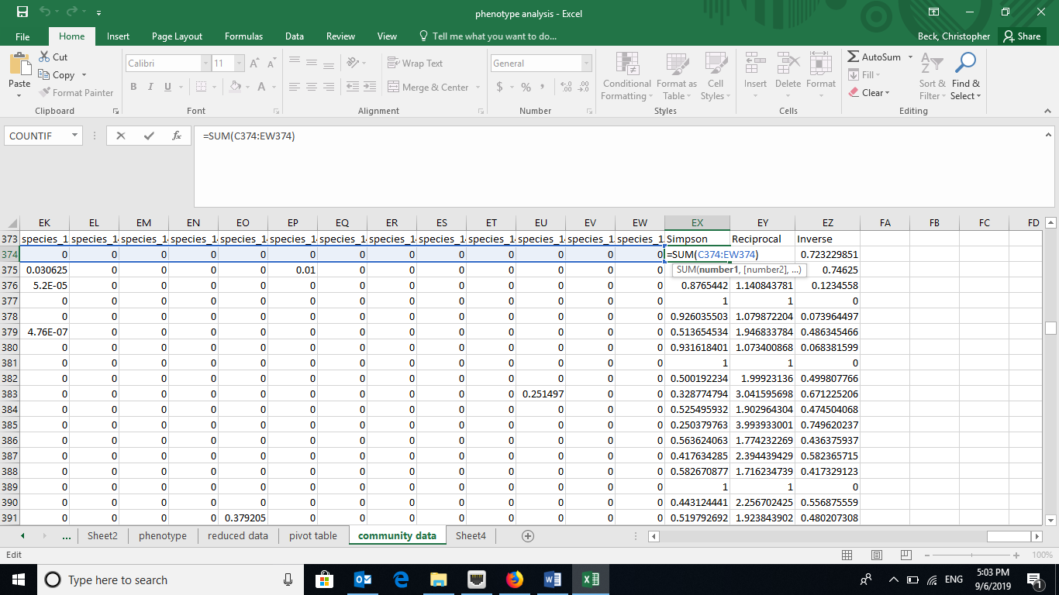
=SUM(C374:EW374). C374 is the first cell in the row and EW374 is the cell with the last proportion for a sample.
  - Calculate the reciprocal (e.g., =1/EX374) and inverse Simpson (e.g., =1-EX374) using formulas in Excel.

- Shannon-Weaver (Shannon-Weiner) Index – also incorporates species (taxon) richness and species (taxon) evenness
  - H=-Ʃplnp, where p is the proportion of individuals of each species (taxon) in a community (i.e., n/N).
  - Create a new data array below the original using the same row labels (treatment variables) and the same column labels (species).
  - Using the grand totals for each community, calculate the proportions (plnp). Using the Excel trick that $ before a column or row prevents Excel from iterating when copying a formula makes this easy.
  - Note that lnp is undefined if p=0, so you can use an “IF” statement in Excel. For example, =IF(C2>0,(C2/$EX2)*LN((C2/$EX2)),"")

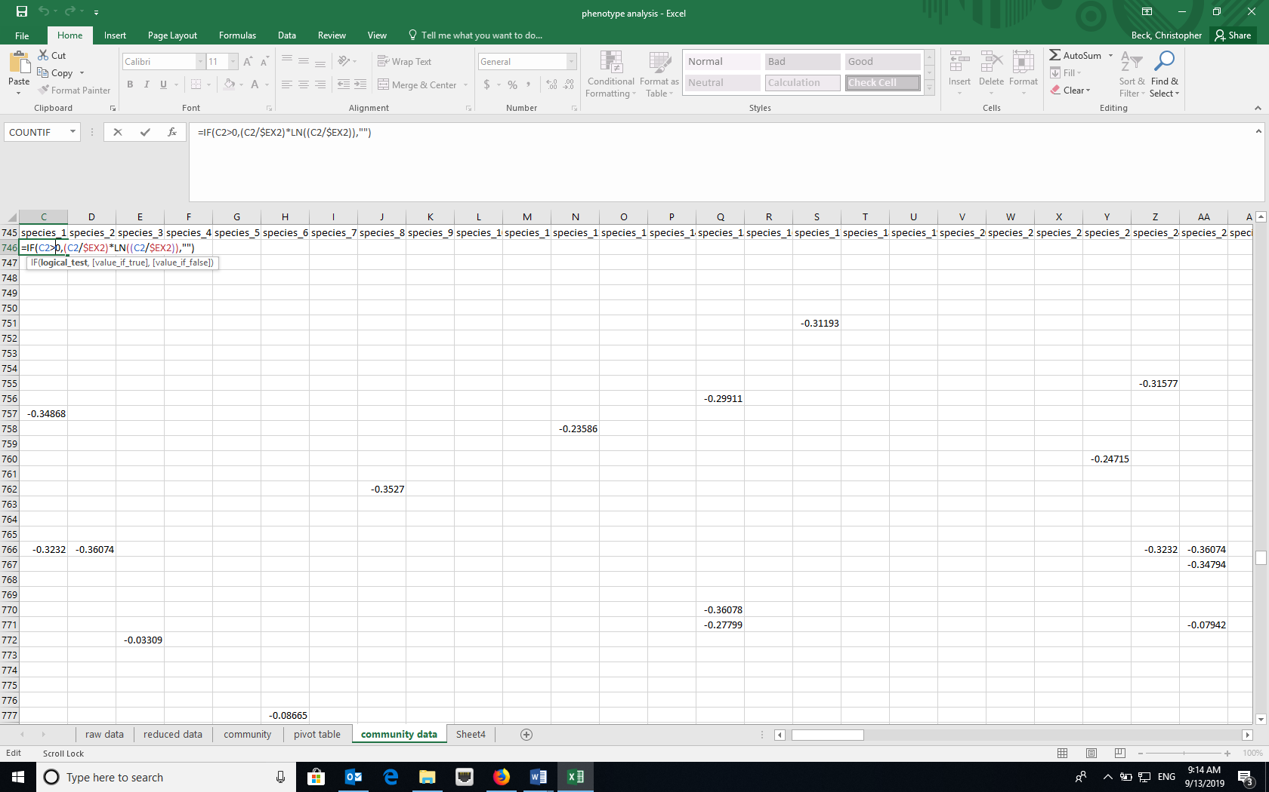
=IF(C2>0,(C2/$EX2)*LN((C2/$EX2)),""). C2 is the cell with the abundance of “species_1” and EX2 is the cell with the grand total for a sample. The $ prevents the column identifier from changing. Copy the formula across the row and then down.

  - Calculate the negative sum of the proportions (plnp) (=-SUM in Excel for each row, a different microbial community) to calculate the Shannon-Weaver Index.

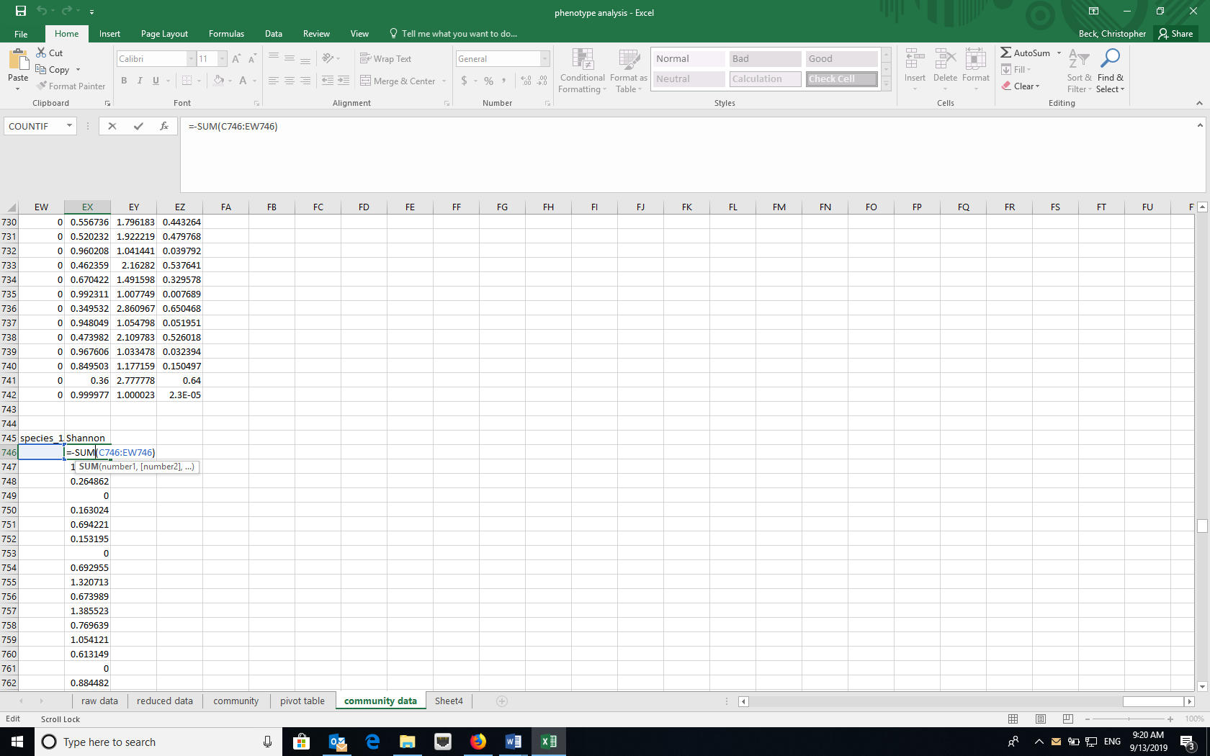
= -SUM(C746:EW746). C746 is the first cell in the row and EW746 is the cell with the last proportion for a sample.

Data Manipulation in R
- Open RStudio and create a new project using the New Project option under File and select for the new project to be in an existing folder where your data are.
- Install the following packages either using the Packages tab in RStudio or the command install.packages(“name_of_package”) in the console. Note that BiodiversityR requires QuartzX on a Mac. If you are using a MacOS and don’t have QuartzX, install it first and restart your computer before install these packages.
  - dplyr
  - reshape2
  - vegan
  - BiodiversityR
  - ggplot2

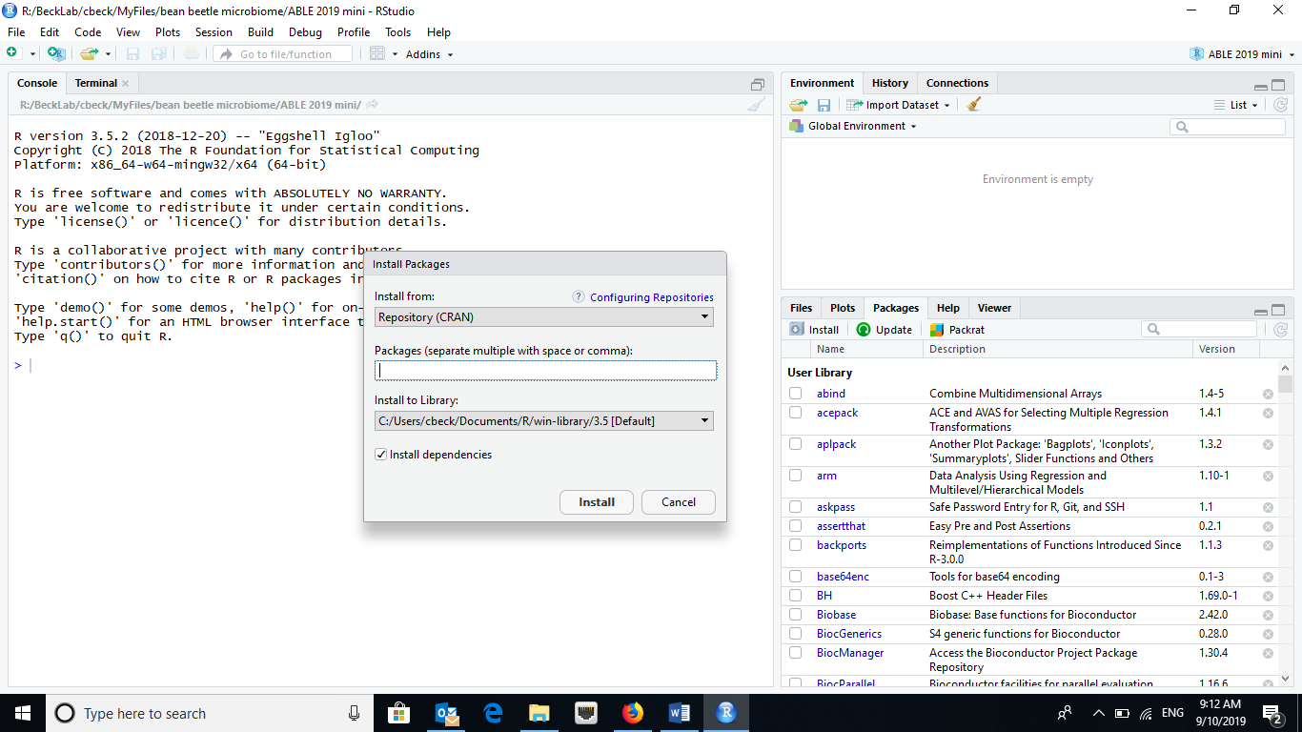
Type the name of the package here and click Install.
- Load the packages listed above by clicking the checkboxes for the appropriate packages in the Packages tab or the command library(“name_of_package”) in the console.
- Import the dataset (“community” that you created above in the Excel section) into RStudio.

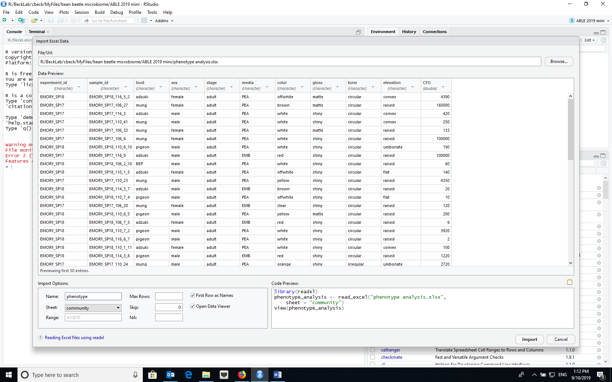
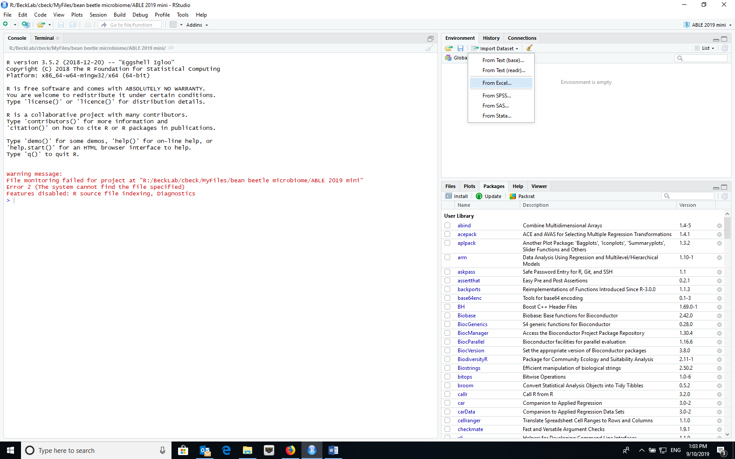
Browse to select file from your computer
Set Name to “phenotype” and use Sheet dropdown to select appropriate worksheet from Excel file.

- Attach the imported dataset to the dataframe using the attach command in the console (attach(phenotype))
- Create a community matrix for each sample. Since each “taxon” is defined by the combination of media type and the four phenotypic characters, we can use the dcast function in the reshape2 library, using the following command.
> comm_pheno=dcast(phenotype,sample_id~media+color+gloss+form+elevation,value.var = "CFU",fun.aggregate = sum)

- The first column in the resulting data table is the sample_id. The sample_id needs to become the row name and then deleted, using the following commands.
> row.names(comm_pheno)<-(comm_pheno$sample_id)
> comm_pheno<-comm_pheno[,-1]

- Now, we need to create an environment matrix with the sample metadata. First, we create a data table with the sample names and sample metadata, which are in the second through fourth columns of the “phenotype” dataframe. Second, we remove all of the duplicate values for the sample_id using the distinct function in the dplyr package. Third, we need the sample_id to become the row name. (Note that this causes an error message and for some reason if you delete the column with the row name, the row names disappear. In this case, we do not need to delete the sample_id column because we can specify the factor of interest.) Last, we need to set host and sex as factors.
> pheno_meta<-phenotype[,2:4]
> pheno_meta<-pheno_meta %>% distinct(sample_id, .keep_all = TRUE)
> row.names(pheno_meta)<-(pheno_meta$sample_id)
> pheno_meta$host<-as.factor(pheno_meta$host)
> pheno_meta$sex<-as.factor(pheno_meta$sex)

You can ignore the error message about setting row names on a tibble being deprecated.
Species accumulation curves
Species accumulation curves are often used to visualize whether all of the taxa in a community have been sampled. As the number of samples increases, the total number of unique species sampled should increase. However, the relationship between the number of samples and the number of unique species should asymptote. If so, we can say that we have sampled the majority of species in the community. However, if the slope of the relationship is steep, this suggests that the community is incompletely sampled.
For each treatment separately, create the data for the species accumulation curve using:
> Accum.label1<-specaccum(comm_pheno,method='exact',permutations = 100,
conditioned=TRUE,gamma='jack1',w=NULL,
subset=pheno_meta$factor_variable=="factor")

factor_variable=="factor" refers to the factor being evaluated such as host in our dataset, and the “factor” is one state of that variable. For example, host==”mung” would do a species accumulation curve for microbiome communities of beetles that emerged from mung beans. Note that two equals signs are necessary

You need to run the command above for each treatment group separately. Change the label and factor terms appropriately for additional analyses.

  - Plot the first species accumulation curve using:

> plot(Accum.label1,col="red")

  - Plot each additional species accumulation curve using:

> plot(Accum.label2, add=TRUE, col="blue")

If the second curve extends beyond the y-axis, replot the curves in the opposite order (i.e., plot curve 2 first and then curve 1).

Calculating diversity indices
You can calculate the diversity indices described above in the Excel exercise using functions in the BiodiversityR package.
- Species Richness
> diversityresult(comm_pheno,index="richness",method="each site")

- Simpson

> diversityresult(comm_pheno,index="Simpson",method="each site")

This calculates the inverse Simpson described above.

> diversityresult(comm_pheno,index="inverseSimpson",method="each site")

This calculates the reciprocal Simpson described above (confusing that it is called in the inverseSimpson).

- Shannon
> diversityresult(comm_pheno,index="Shannon",method="each site")

- To calculate all of the biodiversity indices and merge them with the metadata for future analysis. You can then use this dataset for analysis of differences between treatments with t-tests, ANOVAs, or their non-parametric equivalents.

> pheno_diversity<-diversityvariables(comm_pheno,pheno_meta)

Because the diversityvariables function calculates a range of diversity indices, sometimes an error occurs because a particular index cannot be calculated with the dataset (e.g., requires taking log of zero). If this is the case, you can use the diversityresult function above and place the results in a dataframe. Then, you can combine the dataframes with the metadata using the cbind function.

> Simpson<-diversityresult(comm_pheno,index="Simpson",method="each site")
> Shannon<-diversityresult(comm_pheno,index="Shannon",method="each site")
> pheno_diversity<-cbind(pheno_meta,Simpson,Shannon)

Calculating community similarity (distance)
Sometimes we are interested in how similar (or different) two communities are based on what species (taxa) are present and the relative abundance of those species (taxa) in the two communities. One of the most common measures of distance is the Bray Curtis Dissimilarity. Similarity can be measured as 1-BC.

$${BC}_{ij}=1-\frac{{2C}_{ij}}{S_{i}÷S_{j}}$$
Where:
- i & j are the two samples,
- S_{i} is the total number of specimens counted in sample i,
- S_{j} is the total number of specimens counted in sample j,
- C_{ij} is the sum of only the lesser counts for each taxa found in both sites.
Although Bray-Curtis Dissimilarity is often used in community ecology, it is not robust to incomplete sampling of the community (all taxa are not sampled) or unbalanced sampling (all treatments are not equally sampled). An alternative is the Morista-Horn Index of Dissimilarity (1-C_{H}). Morista-Horn Index of Similarity is
$$C_{H}=\frac{2\sum_{i=1}^{D_{12}}{\frac{X_{i}}{n}\frac{Y_{i}}{m}}}{\sum_{i=1}^{D_{1}}{{\left(\frac{X_{i}}{n}\right)}^{2}+\sum_{i=1}^{D_{2}}{{\left(\frac{Y_{i}}{m}\right)}^{2}}}}$$
Where
- D₁=number of taxa in sample 1
- D₂=number of taxa in sample 2
- D₁₂=number of taxa in shared in both communities
- X_{i}=number of individuals of taxon i in sample 1
- Y_{i}=number of individuals of taxon i in sample 2
- n=total number of individuals in sample 1
- m=total number of individuals in sample 2
So that X_{i}/n and Y_{i}/m are proportion of individuals of taxon i in each of the samples (communities).
To produce a matrix of all of the pair-wise distances between samples using the Bray Curtis index of distance, use the following command.

> vegdist(comm_pheno, method="bray", binary=FALSE, diag=FALSE, upper=FALSE)

To produce a matrix of all of the pair-wise distances between samples using the Morista-Horn index of distance.

> vegdist(comm_pheno, method="horn", binary=FALSE, diag=FALSE, upper=FALSE)

How different (similar) are the communities?
Adonis is an approach to testing whether communities differ based on a treatment. It is the equivalent of an analysis of variance, but comparing distance matrices. “community_adonis” stores the results of the analysis, “comm_pheno” is the community matrix, “factor_variable” is the treatment (e.g., host), and “pheno_meta” is the name of the dataset that has the treatment data for each community. In the code below, we use Morista-Horn to estimate distance between communities.

> community_adonis<-adonis2(comm_pheno ~ factor_variable, data = pheno_meta, method="horn")
> community_adonis

Cited References
Christian N, Whitaker BK, Clay K. 2015. Microbiomes: unifying animal and plant systems through the lens of community ecology theory. Front. Microbiol. 6:1–15.
Cole MF, Acevedo-Gonzalez T, Gerardo NM, Harris EV, Beck CW. 2018. Effect of diet on bean beetle microbial communities. Article 3 In: McMahon K, editor. Tested studies for laboratory teaching. Volume 39. Proceedings of the 39th Conference of the Association for Biology Laboratory Education (ABLE).
Costello EK, Stagaman K, Dethlefsen L, Bohannan BJM, Relman DA. 2012. The application of ecological theory toward an understanding of the human microbiome. Science. 336:1255–1262
Engel P, Moran NA. 2013. The gut microbiota of insects – diversity in structure and fuction. FEMS Microbiol. Rev. 37:699-735.
Krebs CJ. 1999. Ecological Methodology, 2nd edition. New York: Benjamin Cummings.
McFall-Ngai M, Hadfield MG, Bosch TCG, Carey HV, Domazet-Lošo T, Douglas AE, Dubilier N, Eberl G, Fukami T, Gilbert SF, Hentschel U, King N, Kjelleberg S, Knoll AH, Kremer N, Mazmanian SK, Metcalf JL, Nealson K, Pierce NE, Rawls JF, Reid A, Ruby EG, Rumpho M, Sanders JG, Tautz D, Wernegreen JJ. 2013. Animals in a bacterial world, a new imperative for the life sciences. Proc. Natl. Acad. Sci. U.S.A. 110:3229–3236.
The Human Microbiome Consortium. 2012. Structure, function and diversity of the healthy human microbiome. Nature 486: 207-214.
Young E. 2016. I Contain Multitudes: The Microbes Within Us and a Grander View of Life. New York: HarperCollins Publishers.

This study is based on Blumer LS, Beck CW 2020. Introducing community ecology and data skills with the bean beetle microbiome project. Advances in Biology Laboratory Education 41.
Microbial Community Analysis Using Colony-based Sequencing Database
Student Handout

Objectives

  - Manipulate large datasets to conduct community-level ecological analyses
  - Use community-level data to address questions about insect microbiomes
  - Use Excel or RStudio programs to calculate community ecology variables
  - Compare microbial community using community ecology variables

Introduction

Microbiomes are the communities of microbes (bacteria, viruses, fungi and archaea) living symbiotically with all metazoans. In the past decade, both interest and research on microbiomes, including their implications for human health, have increased dramatically (Christian et al. 2015, Costello et al. 2012, McFall-Ngai et al. 2013, The Human Microbiome Consortium 2012, Young 2016). Insects have been used as model species to study the importance of microbiomes, because of their ease of use and the fact that microbial communities play diverse roles in insects (Engel and Moran 2013).

The data that are collected in any microbiome study consists of lists of the taxonomic units identified and their abundance. The same types of data are evaluated in an ecological community analysis, but now the communities are the collections of microbes that constitute different microbiomes. The community variables, “species” richness and relative abundance, are the same and the statistical methods used to compare communities, diversity and difference indices, also are the same. Perhaps the simplest measure of community structure used by ecologists is “species” or taxon richness, a count of the number of unique taxa in a sample. However, species richness does not consider the relative abundance of species in a community. Imagine two communities with five different species. In one community, all of the species have the same relative abundance. In the other community, one species dominates comprising 95% of individuals in the community. The other four species are very rare. Based on species richness as a measure of community structure, these two communities are the same, although they are clearly very different. As a result, ecologists use other species diversity indices that consider both the number of species and the relative abundance of species in a community. Two common indices are the Simpson Index and the Shannon-Weaver Index. Communities with greater numbers of species and higher evenness (i.e., similar relative abundance of species within a community) are considered more diverse. Finally, measures of species richness and species diversity do not consider the identity of species in a community. So, communities could have the same level of species diversity, but have completely different species. Measure of community similarity, such as the Bray-Curtis Index, compare the similarity (or dissimilarity) between two communities based on the identity of species in the communities, as well as their relative abundances. For more information on indices of species diversity and measures of community similarity, see Krebs (1999).
In this study, bean beetle gut microbiome data were collected by undergraduate students using the protocols developed by Cole et al. (2018). Three types of data were collected: colony phenotypes from cultured bacteria, 16s rRNA gene sequencing of specific bacterial colonies, and whole community 16s rRNA gene sequencing, but we will limit our analyses to the colony phenotype and colony-based 16s data.
Questions
Using data from the colony-based sequencing database and the analyses described below, answer the following questions.
- Which taxa are most prevalent in the bacterial communities in bean beetles?
- Do the most prevalent taxa vary based on host bean type?
- Based on the diversity indices that you calculated, which treatment had the highest (lowest) diversity?
- Does the answer depend on the measure of species (taxon) diversity that you use?
- Is there a relationship between number of samples and taxonomic diversity? If so, what might explain this?
- Which communities are most similar (different)?
- Do your answers to the questions above depend on the taxonomic level of analysis?
Database description
This database contains data for the microbial community of bean beetles based on 16s rRNA sequencing of individual bacterial colonies cultured from bean beetle homogenates plated on different media. Since only a small number of colonies are sequenced from each plate, the data do not represent the entire microbial community for a particular sample. However, qualitative comparisons can be made based on bean host species, sex of beetle, and other variables.
Access the database at https://www.beanbeetles.org/microbiome/colony-database-search/.
The database allows you to limit your search by bean host type, sex, life cycle stage, media on which bacteria were grown, colony phenotype, and bacterial taxonomy. Since we are interested in making comparisons between bacterial communities based on host species and sex, we want to download the entire database. Clicking “Submit” without limiting the search will allow you to view all of the data.
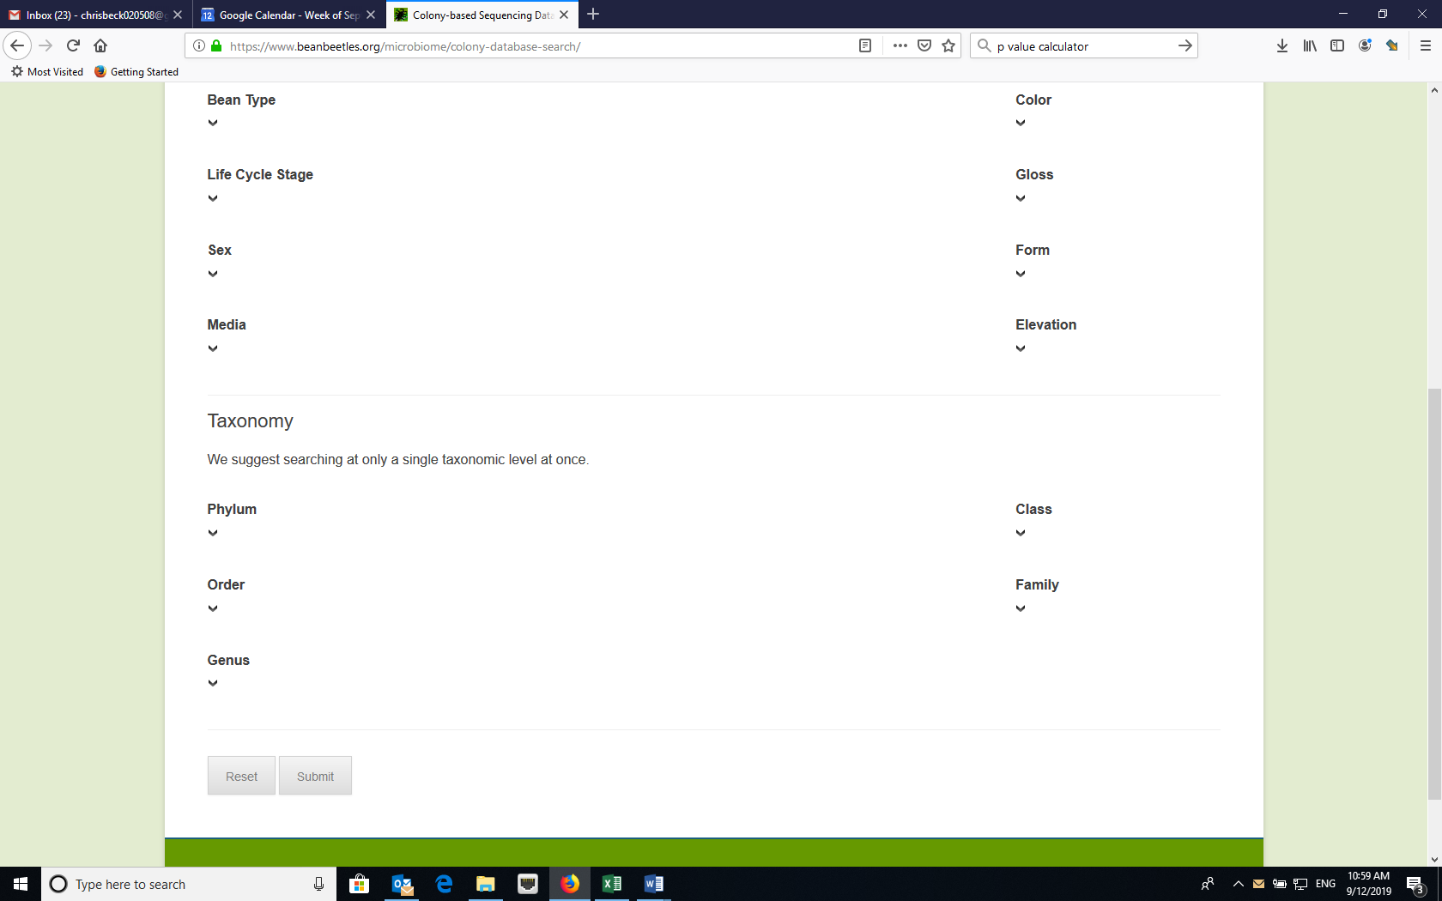
Downloading Data
While we can view the data on the website, we want to download the data to manipulate. Click the download link to download a csv file with the data. Then, save the file as an Excel file (name the file “colony-based sequence data”) and rename the tab “raw data.”
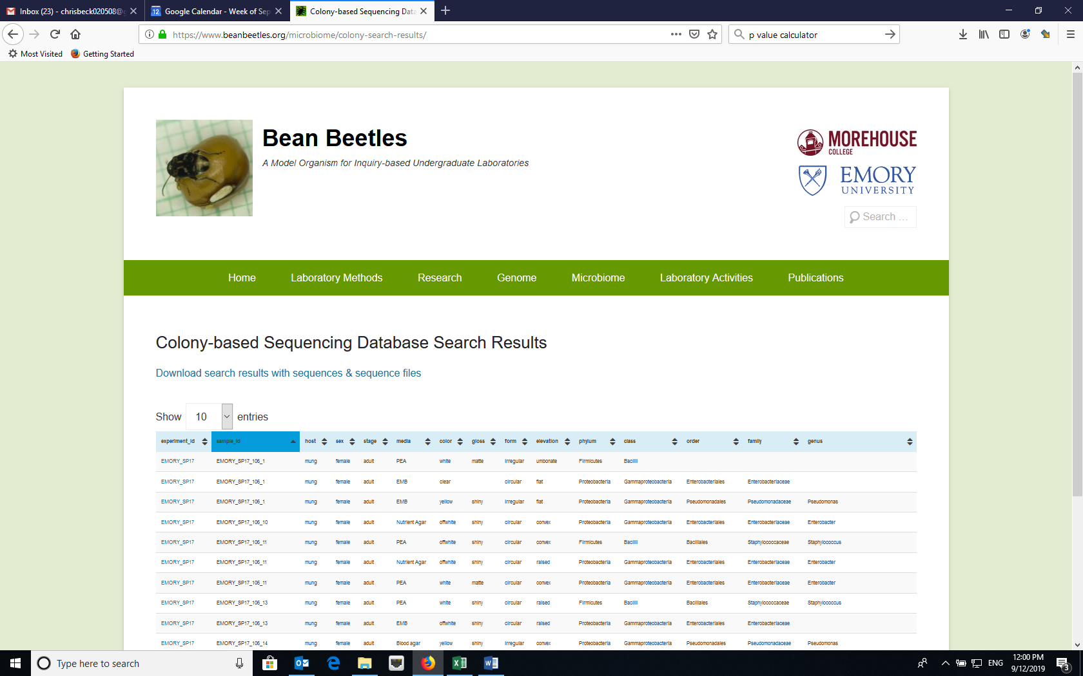
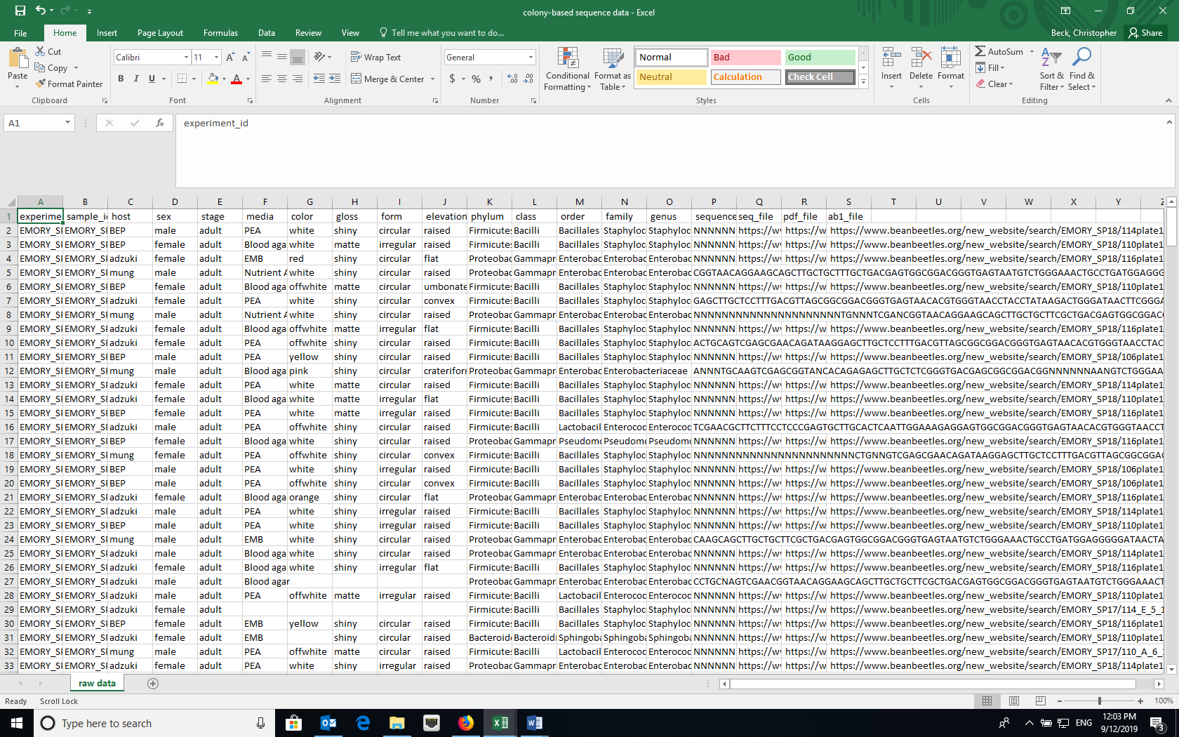
Double click tab and rename as “raw data”
Data Reduction
- Make a copy of the raw data in a new sheet using the sheet copy function in Excel (right click on the tab and select “Move or copy” and rename the tab (“reduced raw data”).
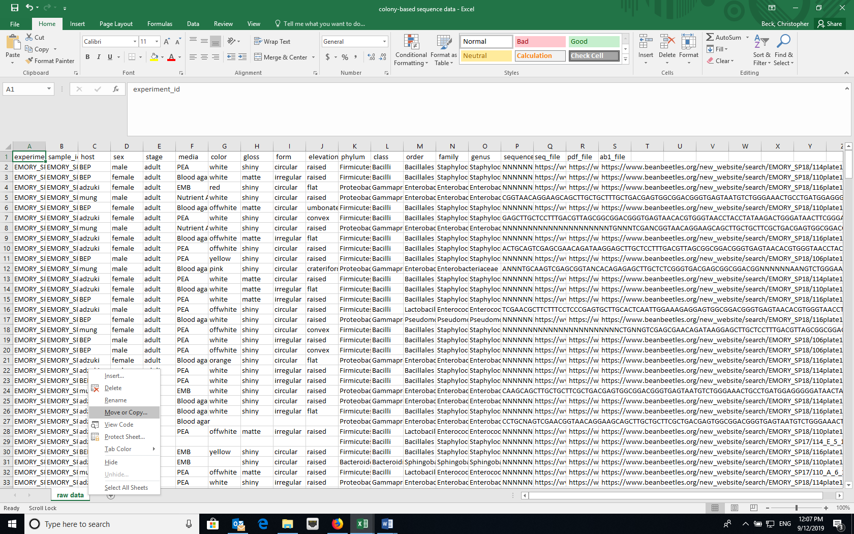
Right click on tab and select “Move or Copy”.
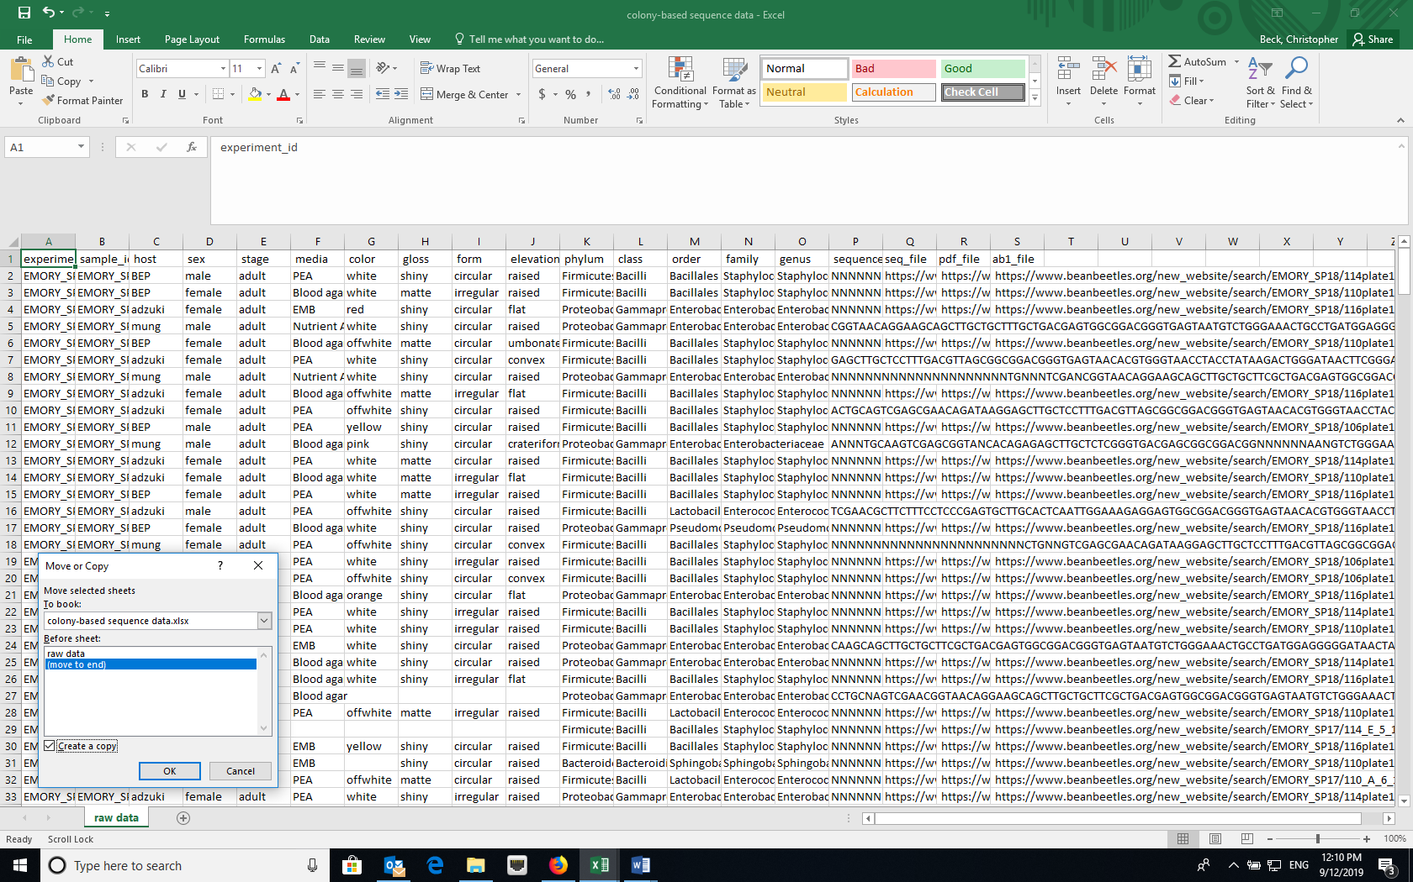
Select “Move to end” and check “Create a copy”
- In the “reduced raw data” sheet, delete any columns that we don’t need, such as the colony phenotype (color, gloss, form, elevation) and sequence data columns. The “reduced raw data” sheet is the data source if you choose to analyze these data in RStudio. Additional data manipulation and formatting (below) is required if you choose to analyze these data in Excel.
Data manipulation
- We need to consolidate the data for each host species, each sex, or the combination of the two by the bacterial taxa. The easiest way to do this is with the Pivot Table function in Excel.
- When clicked on a cell within the data, create a Pivot Table (Insert -> Pivot Table OR Data -> Summarize with Pivot Table). Make sure that the data source includes the top row (the cell range should include “$A$1”), which has the column headings. Click OK to create the pivot table in a new worksheet and label the tab “pivot table”.
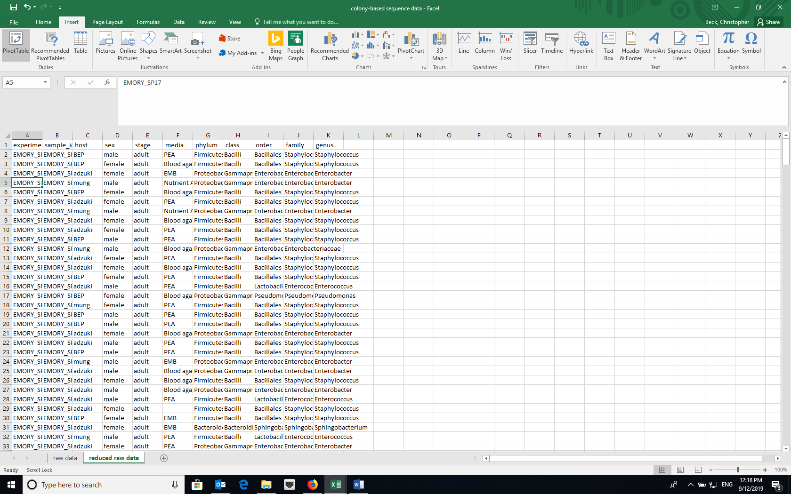
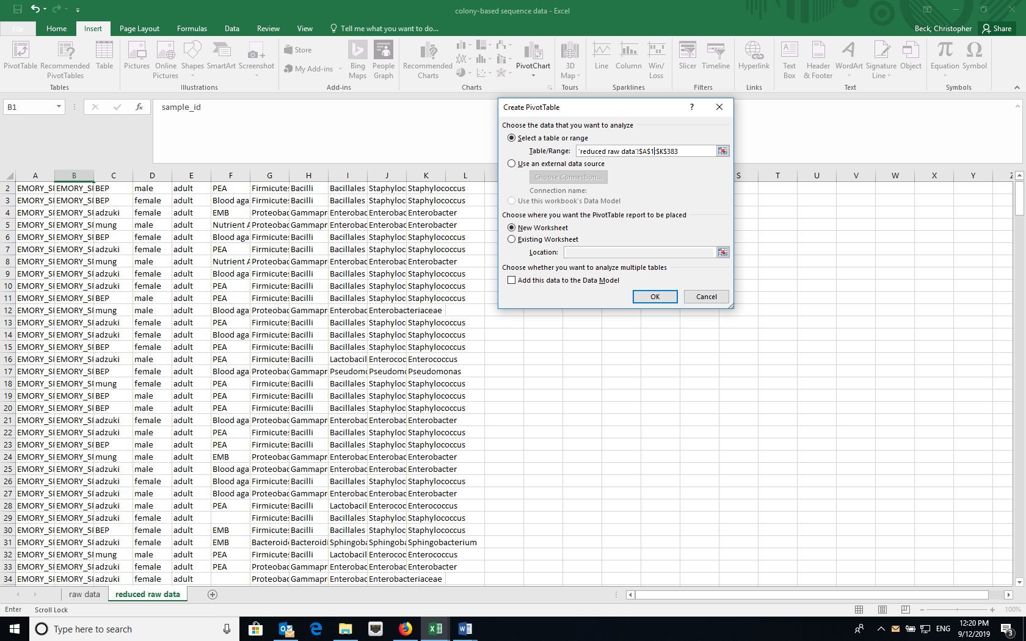
Make sure that the cell range includes $A$1
- Set the treatment(s) that you are interested (for example, host species) in as the rows and the bacterial taxonomic level you are interested in as the columns. The Values should be a COUNT of the sample_id, as each row in the dataset represents a single sample.

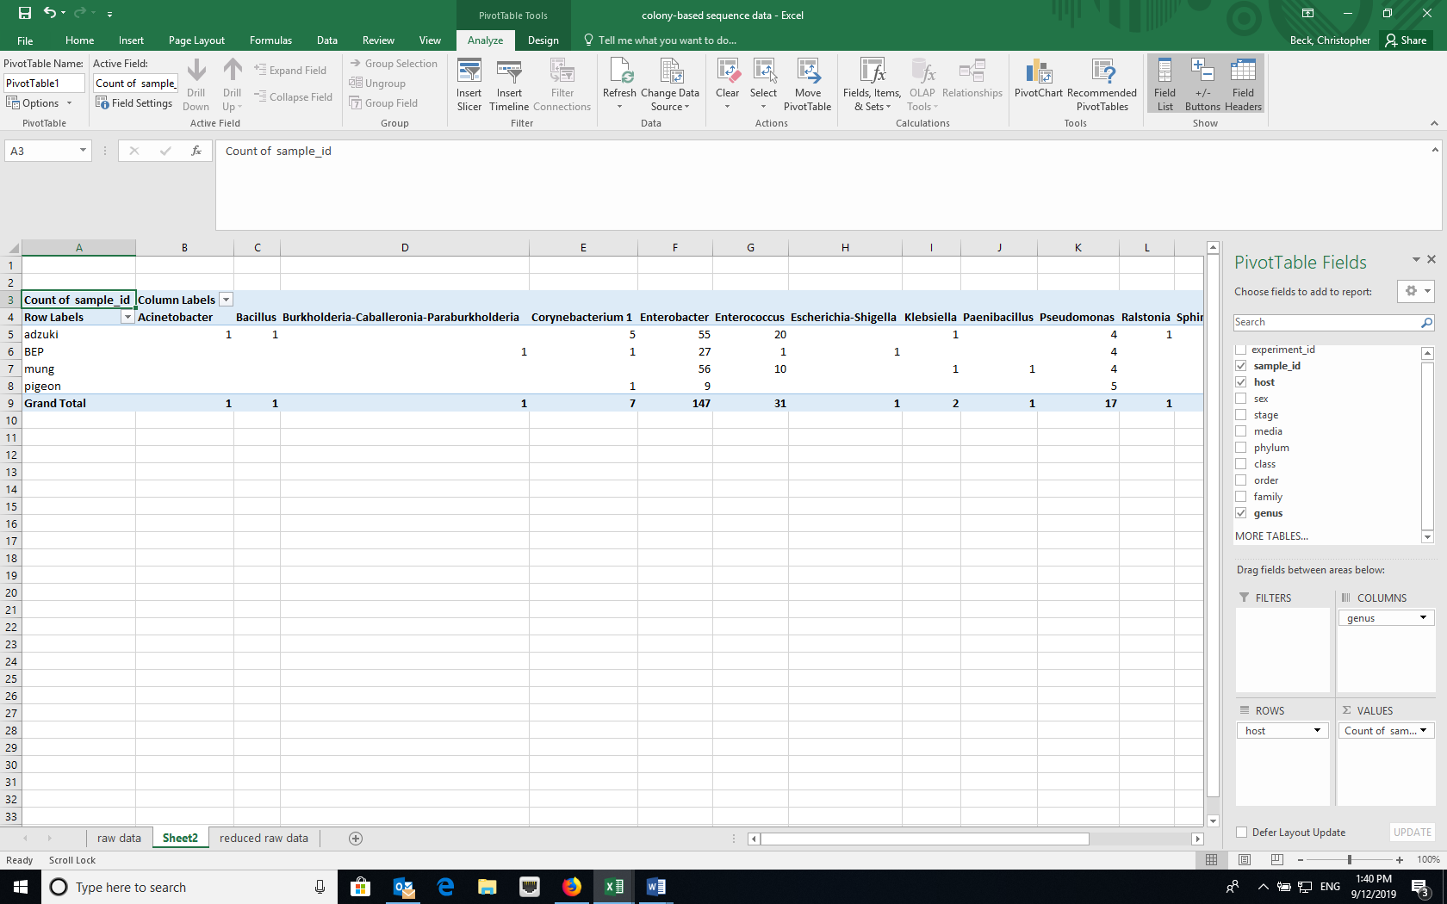
Drag treatment of interest (e.g., host) to ROWS, taxonomic level (e.g., genus) to COLUMNS, and sample_id to VALUES

- You can add zeros to all of the empty cells in the Pivot Table using the Options menu and remove the Grand totals for Columns using the Options menu or the Design tab depending of your version of Excel. (You want to keep the Grand totals for rows to calculate diversity indices.)

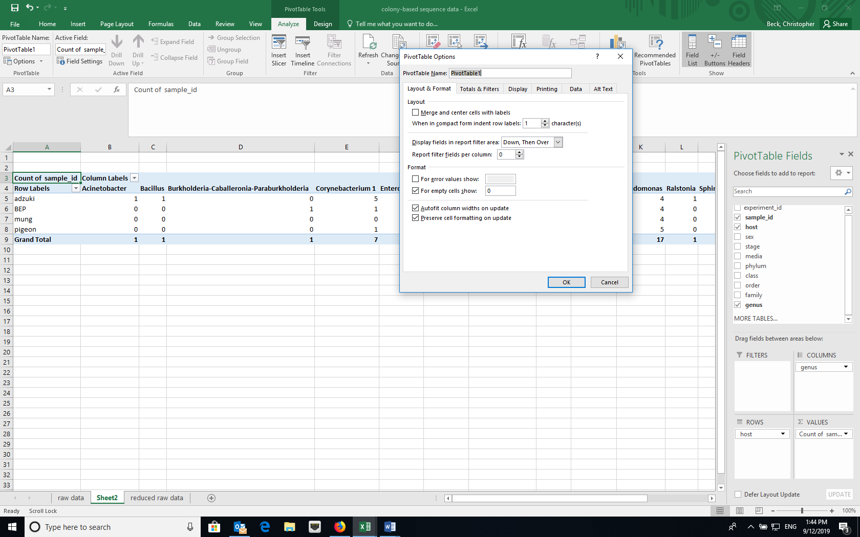
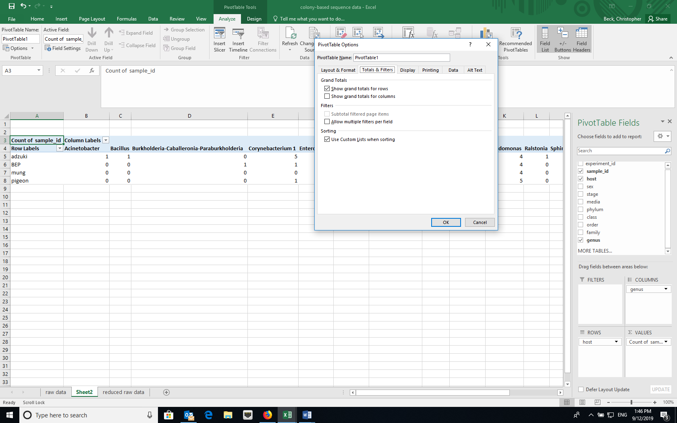
Unselect checkbox for “Show grand totals for columns”
- You can remove the “blanks” column using the Column labels dropdown (located at upper left of the sheet) and unselecting “blank”.
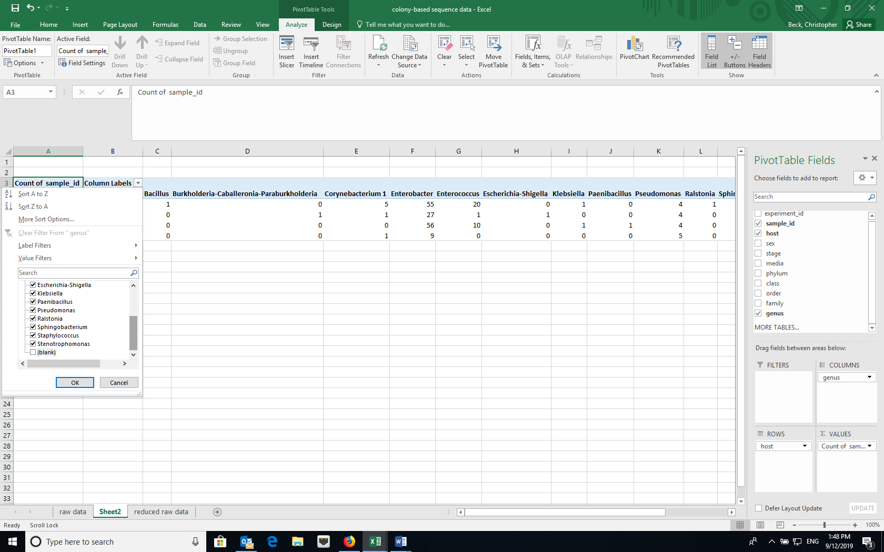
Unselect checkbox for “blanks”
- If you selected more than one treatment for the rows, you can get the treatment data to repeat for each sample. In the Design tab, select “Report Layout” and choose “Show in Tabular form” and “Repeat All Item Labels”.
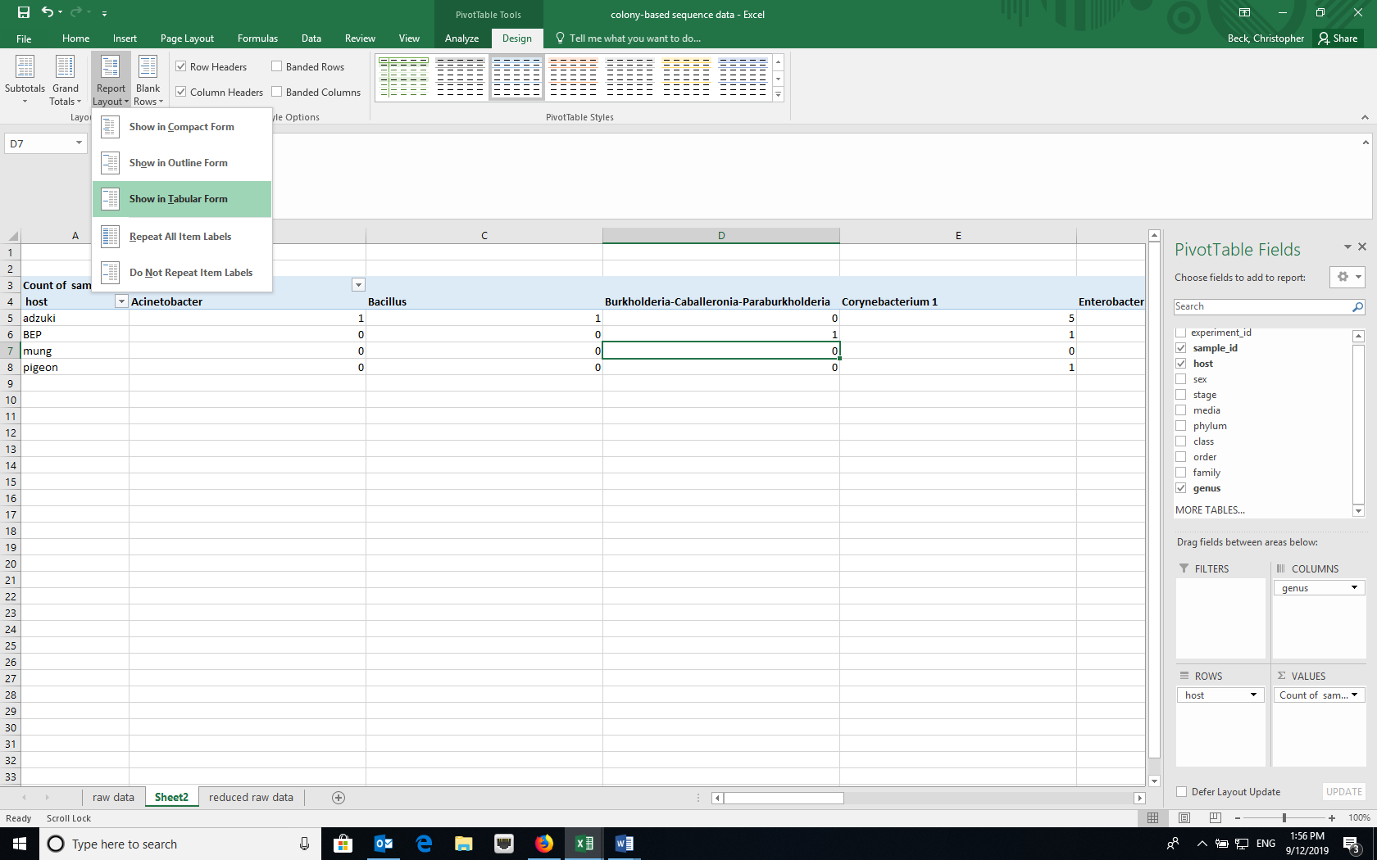
- Copy and paste (as values) the pivot table to a new worksheet and remove any extra rows at the top. The top row should now have the taxa names. Name this tab “analysis”. Conduct the community ecology analyses that follow in Excel on the “analysis” sheet.
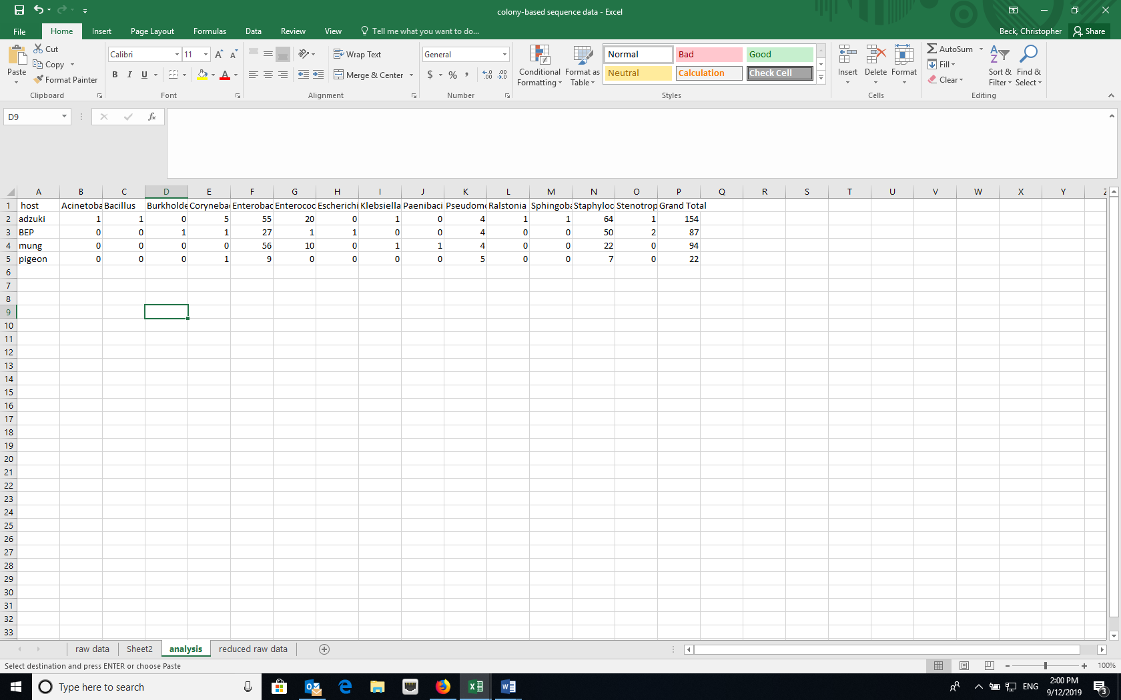
Calculating diversity indices
- Species (taxon) richness – the number of unique species (taxa) in a sample
  - Although you could manually count the number of cells with values greater than zero for each treatment, using the COUNTIF formula in Excel is easier (e.g., =COUNTIF(range,”>0”)). Where “range” is the cell range in the datasheet, for example “C2:M2”, a single row or treatment.
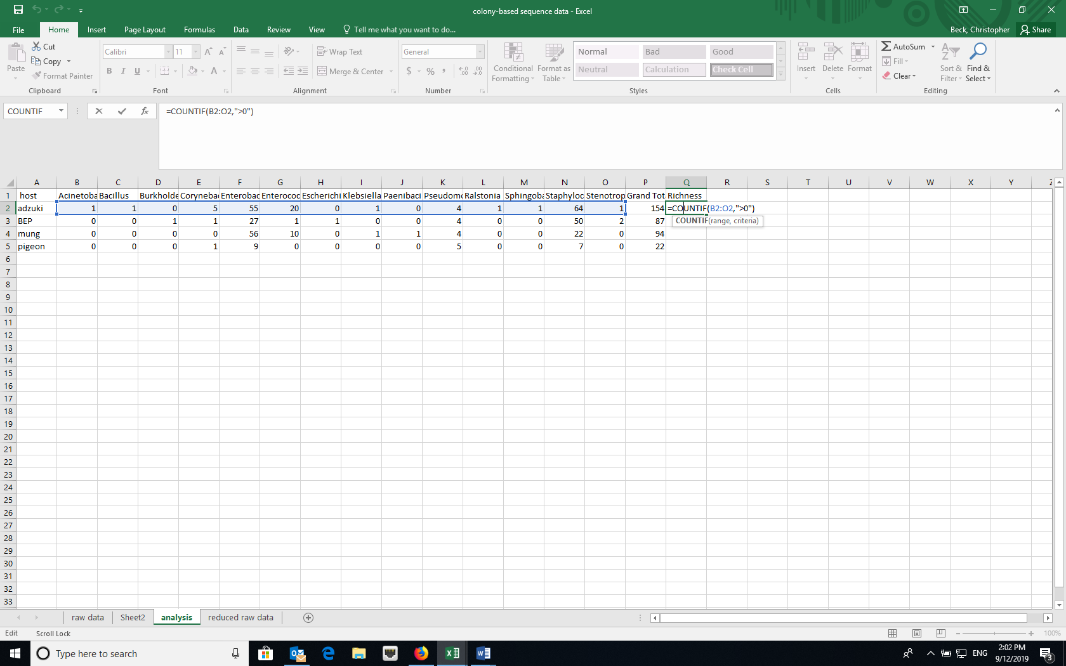
- Simpson Index – the Simpson Index incorporates both species (taxon) richness and species (taxon) evenness.
  - D = Ʃ(n/N)^2, where n=number of individuals of a particular species (taxon) and N=total number of individuals in a sample. D increases as diversity decreases, which is counterintuitive. A reciprocal or inverse index would be more intuitive and are easily calculated.
  - Reciprocal Simpson = 1/D and scales so the maximum value is the species richness of a community.
  - Inverse Simpson = 1-D and scales to a maximum value of 1.0.
  - Create a new data array below the original using the same row labels (treatment variables) and the same column labels (bacterial taxa).
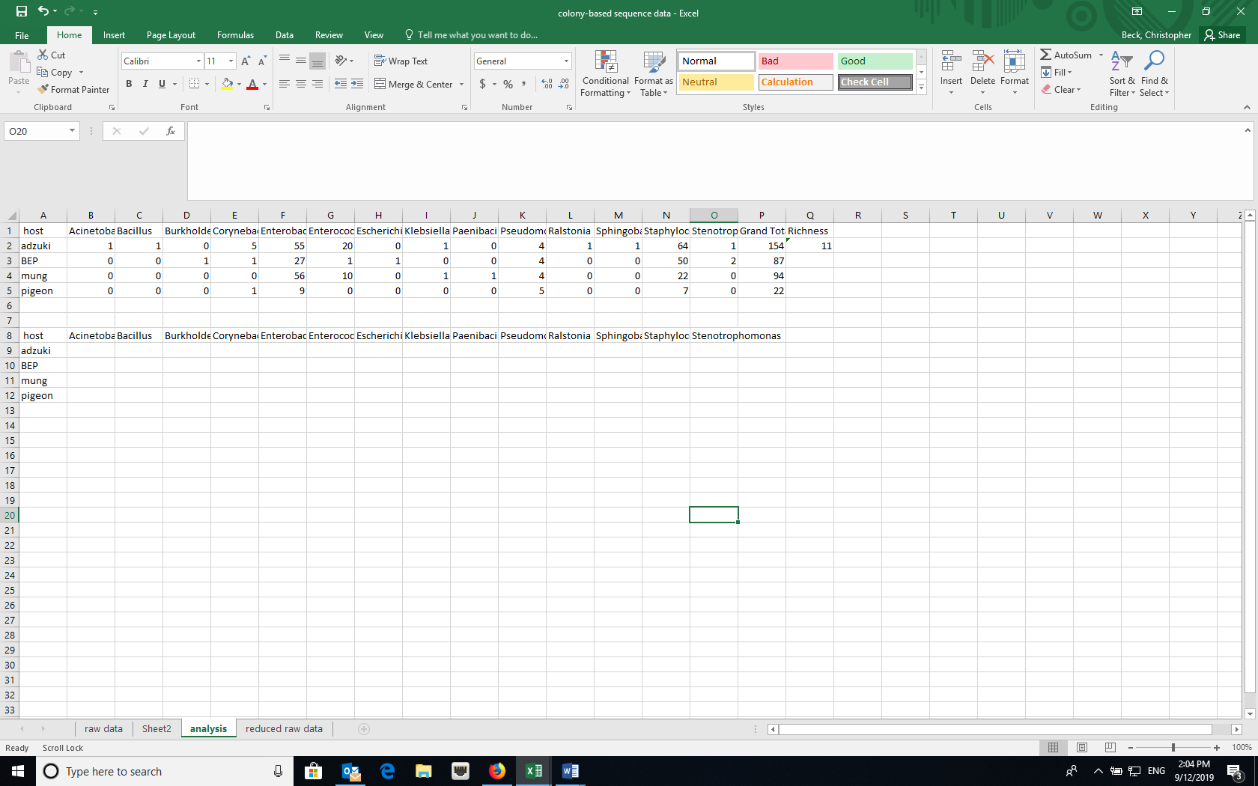
  - To calculate the proportion squared for each taxa, use the grand totals for each treatment. Using the Excel trick that $ before a column or row prevents Excel from iterating when copying a formula makes this easy. For example, =(C2/$P2)^2. Copy the formula across the row and then down.
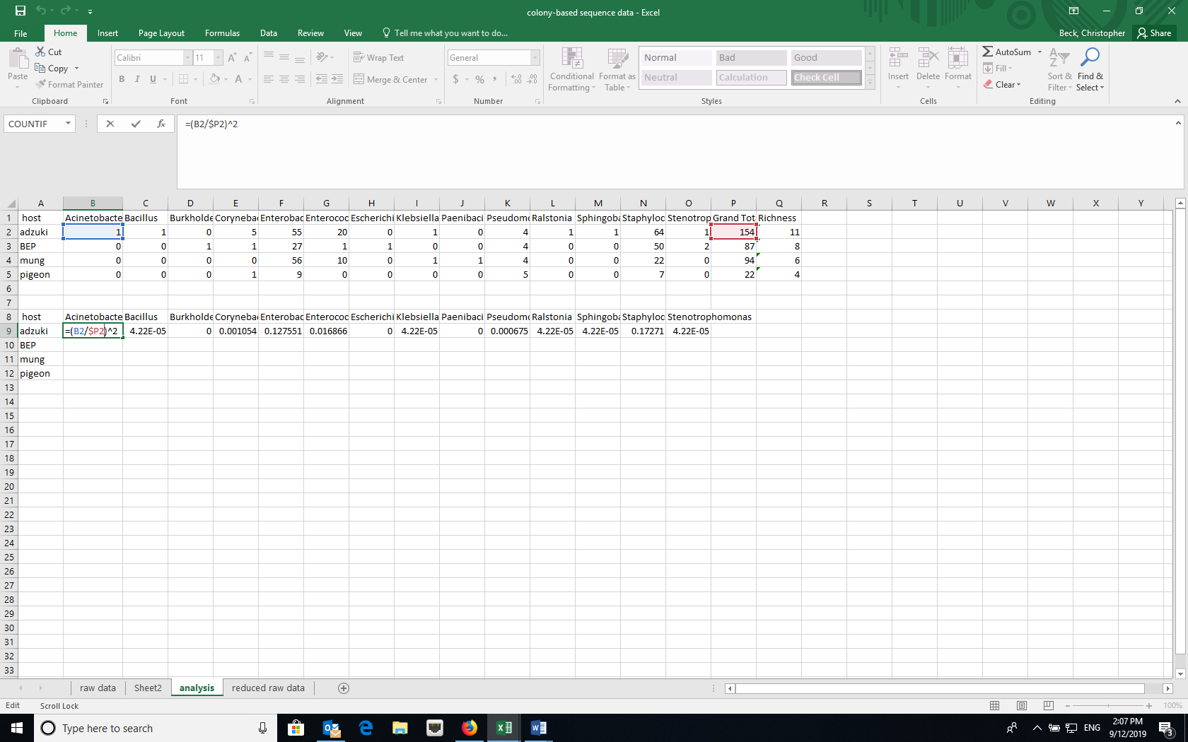
=(B2/$P2)^2. B2 is the cell with the abundance of the first taxon and P2 is the cell with the grand total for a treatment. The $ prevents the column identifier from changing. Copy the formula across the row and then down.

  - Calculate the sum of the proportions squared (=SUM in Excel) to calculate the Simpson Index.
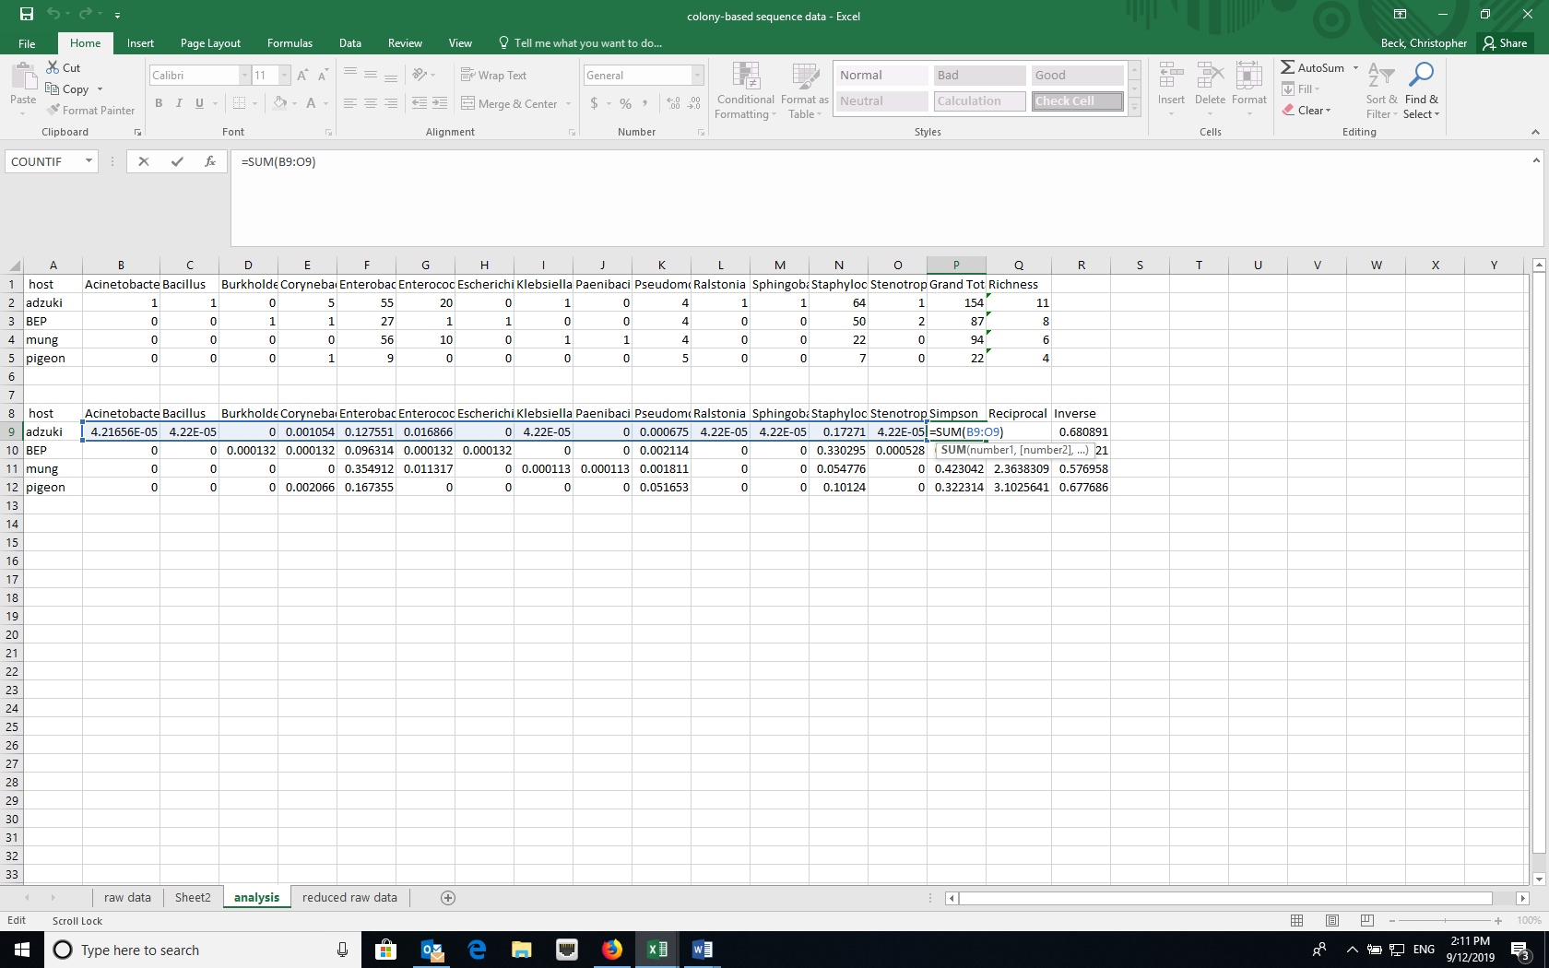
=SUM(C9:O9). C9 is the first cell in the row and O9 is the cell with the last proportion for a treatment.
  - Calculate the reciprocal (e.g., =1/P9) and inverse Simpson (e.g., =1-P9) using formulas in Excel.

- Shannon-Weaver (Shannon-Weiner) Index – also incorporates species (taxon) richness and species (taxon) evenness
  - H=-Ʃplnp, where p is the proportion of individuals of each bacterial taxon in a community (i.e., n/N).
  - Create a new data array below the original using the same row labels (treatment variables) and the same column labels (species).
  - Using the grand totals for each treatment, calculate the proportions (plnp). Using the Excel trick that $ before a column or row prevents Excel from iterating when copying a formula makes this easy.
  - Note that lnp is undefined if p=0, so you can use an “IF” statement in Excel. For example, =IF(B2>0,(B2/$P2)*LN((B2/$P2)),"")
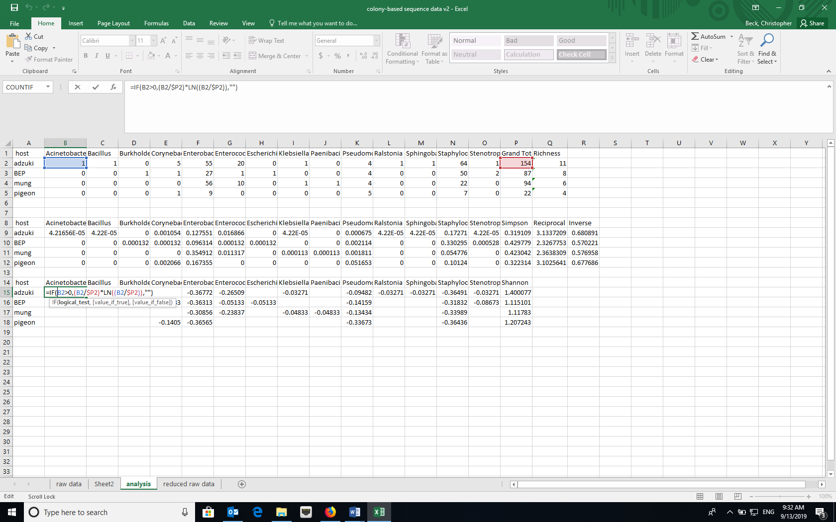
=IF(B2>0,(B2/$P2)*LN((B2/$P2)),""). B2 is the cell with the abundance of the first taxon and P2 is the cell with the grand total for a treatment. The $ prevents the column identifier from changing. Copy the formula across the row and then down.

  - Calculate the negative sum of the proportions (plnp) (=-SUM in Excel for each row, a different microbial community) to calculate the Shannon-Weaver Index.

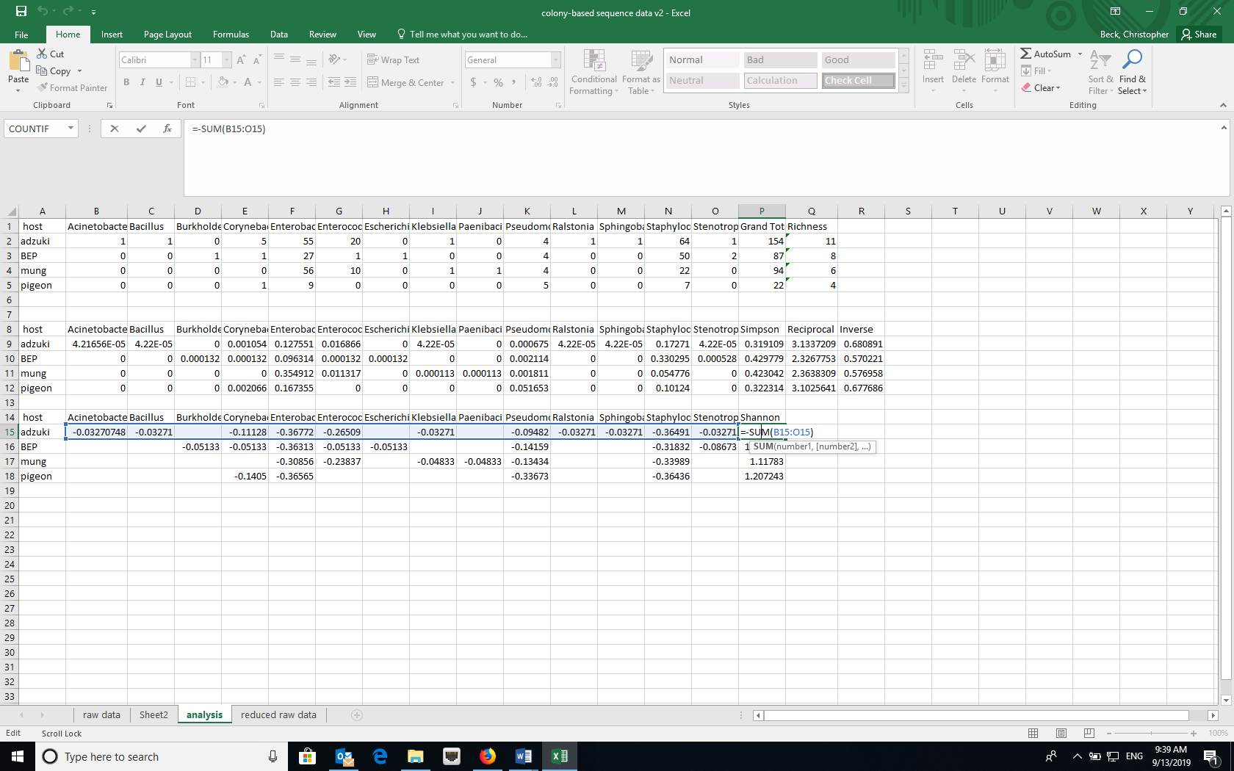
= -SUM(B15:O15). B15 is the first cell in the row and O15 is the cell with the last proportion for a treatment.

Data Manipulation in R
- Open RStudio and create a new project using the New Project option under File and select for the new project to be in an existing folder where your data are.
- Install the following packages either using the Packages tab in RStudio or the command install.packages(“name_of_package”) in the console. Note that BiodiversityR requires QuartzX on a Mac. If you are using a MacOS and don’t have QuartzX, install it first and restart your computer before install these packages.
  - dplyr
  - reshape2
  - vegan
  - BiodiversityR
  - ggplot2

Type the name of the package here and click Install.
- Load the packages listed above by clicking the checkboxes for the appropriate packages in the Packages tab or the command library(“name_of_package”) in the console.
- Import the dataset “reduced raw data” (dataset without the extra metadata that you created in the Excel section) into RStudio.

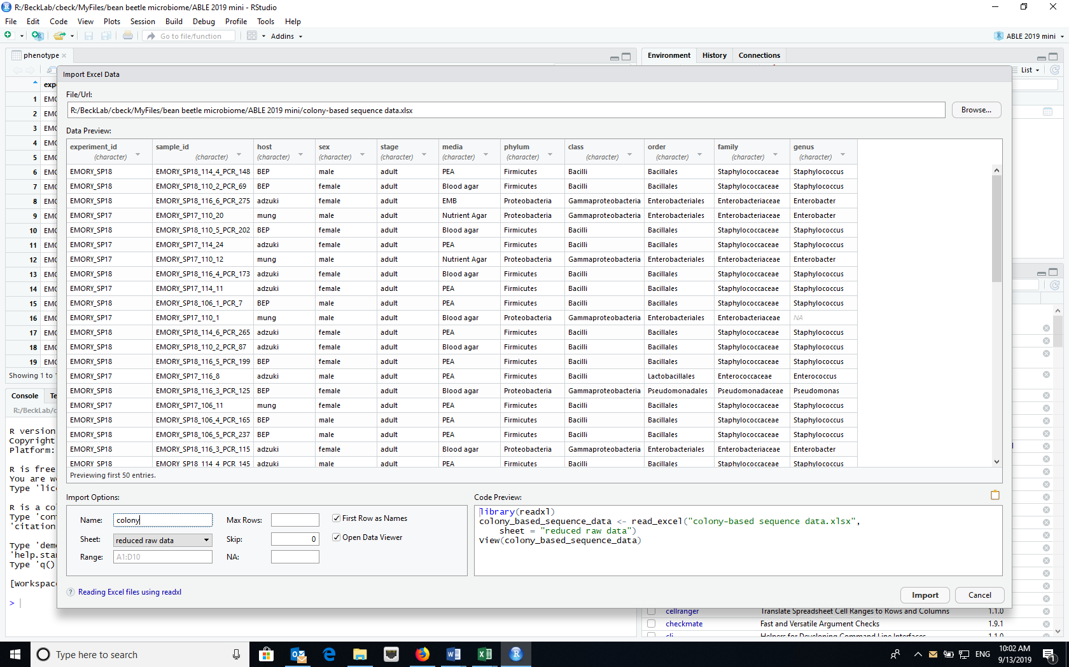
Set Name to “colony” and use Sheet dropdown to select appropriate worksheet from Excel file.
Browse to select file from your computer

- Attach the imported dataset (“colony”) to the dataframe using the attach command in the console (attach(colony))
- Create a community matrix (named “community” in this example) for a particular treatment. This example assumes that you are doing the analysis at the genus level. This can be changed to other taxonomic levels using the appropriate variable name

>community<-table(host,genus)
- If you want to look at two factors at the same time, creating the community matrix is a little more complicated. The first command calculates the count of each genus by each sex and host combination and drops any missing values. The second command creates a community matrix.

> community_2 <- colony %>% count(sex,host,genus) %>% drop_na()
> comm2<-dcast(community_2, sex+host~genus, value.var = "n", fun.aggregate = sum)
“genus” in both command lines may be whatever taxon level you wish to evaluate in the dataset. For example, it could be changed to “family” or “order”.
Calculating diversity indices
Note: “community” is the name of the community matrix
- Species Richness

> diversityresult(community,index="richness",method="each site")

- Simpson

> diversityresult(community,index="Simpson",method="each site")

This calculates the inverse Simpson described above

> diversityresult(community,index="inverseSimpson",method="each site")

This calculates the reciprocal Simpson described above. (confusing that it is called in the
inverseSimpson)

- Shannon

> diversityresult(community,index="Shannon",method="each site")

Calculating community similarity (distance)
Sometimes we are interested in how similar (or different) two communities are based on what species (taxa) are present and the relative abundance of those species (taxa) in the two communities. One of the most common measures of distance is the Bray Curtis Dissimilarity. Similarity can be measured as 1-BC.

$${BC}_{ij}=1-\frac{{2C}_{ij}}{S_{i}÷S_{j}}$$
Where:
- i & j are the two samples,
- S_{i} is the total number of specimens counted in sample i,
- S_{j} is the total number of specimens counted in sample j,
- C_{ij} is the sum of only the lesser counts for each taxa found in both sites.
Although Bray-Curtis Dissimilarity is often used in community ecology, it is not robust to incomplete sampling of the community (all taxa are not sampled) or unbalanced sampling (all treatments are not equally sampled). An alternative is the Morista-Horn Index of Dissimilarity (1-C_{H}). Morista-Horn Index of Similarity is
$$C_{H}=\frac{2\sum_{i=1}^{D_{12}}{\frac{X_{i}}{n}\frac{Y_{i}}{m}}}{\sum_{i=1}^{D_{1}}{{\left(\frac{X_{i}}{n}\right)}^{2}+\sum_{i=1}^{D_{2}}{{\left(\frac{Y_{i}}{m}\right)}^{2}}}}$$
Where
- D₁=number of taxa in sample 1
- D₂=number of taxa in sample 2
- D₁₂=number of taxa in shared in both communities
- X_{i}=number of individuals of taxon i in sample 1
- Y_{i}=number of individuals of taxon i in sample 2
- n=total number of individuals in sample 1
- m=total number of individuals in sample 2
So that X_{i}/n and Y_{i}/m are proportion of individuals of taxon i in each of the samples (communities).

To produce a matrix of all of the pair-wise distances between samples using the Bray Curtis index of distance, use the following command.

> vegdist(community, method="bray", binary=FALSE, diag=FALSE, upper=FALSE)

To produce a matrix of all of the pair-wise distances between samples using the Morista-Horn index of distance.

> vegdist(community, method="horn", binary=FALSE, diag=FALSE, upper=FALSE)

Cited References
Christian N, Whitaker BK, Clay K. 2015. Microbiomes: unifying animal and plant systems through the lens of community ecology theory. Front. Microbiol. 6:1–15.
Cole MF, Acevedo-Gonzalez T, Gerardo NM, Harris EV, Beck CW. 2018. Effect of diet on bean beetle microbial communities. Article 3 In: McMahon K, editor. Tested studies for laboratory teaching. Volume 39. Proceedings of the 39th Conference of the Association for Biology Laboratory Education (ABLE).
Costello EK, Stagaman K, Dethlefsen L, Bohannan BJM, Relman DA. 2012. The application of ecological theory toward an understanding of the human microbiome. Science. 336:1255–1262
Engel P, Moran NA. 2013. The gut microbiota of insects – diversity in structure and fuction. FEMS Microbiol. Rev. 37:699-735.
Krebs CJ. 1999. Ecological Methodology, 2nd edition. New York: Benjamin Cummings.
McFall-Ngai M, Hadfield MG, Bosch TCG, Carey HV, Domazet-Lošo T, Douglas AE, Dubilier N, Eberl G, Fukami T, Gilbert SF, Hentschel U, King N, Kjelleberg S, Knoll AH, Kremer N, Mazmanian SK, Metcalf JL, Nealson K, Pierce NE, Rawls JF, Reid A, Ruby EG, Rumpho M, Sanders JG, Tautz D, Wernegreen JJ. 2013. Animals in a bacterial world, a new imperative for the life sciences. Proc. Natl. Acad. Sci. U.S.A. 110:3229–3236.
The Human Microbiome Consortium. 2012. Structure, function and diversity of the healthy human microbiome. Nature 486: 207-214.
Young E. 2016. I Contain Multitudes: The Microbes Within Us and a Grander View of Life. New York: HarperCollins Publishers.

This study is based on Blumer LS, Beck CW 2020. Introducing community ecology and data skills with the bean beetle microbiome project. Advances in Biology Laboratory Education 41.

